**Monitoring Dashboard**

You can check the monitoring information aggregated by the service group unit defined by the customer.

The Monitoring Dashboard service provides three menus.

1. Service Dashboard

Provides monitoring of infrastructure resources and alarms for abnormal infrastructure threshold.

Monitoring Dashboard > Service Dashboard

* 1. Service Group List

Shows the service group list and provides convenient navigation between target services you want to monitor.

Provides information with the service list of the customer managed by the person in charge and incurred alarm summary.

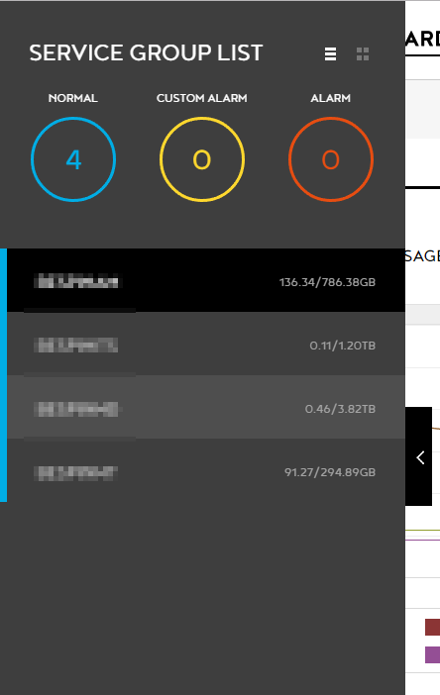 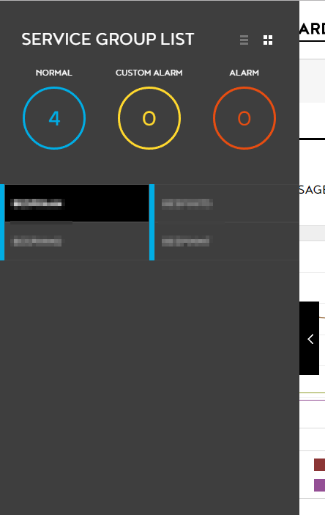

* 1. Service Summary

Overall status, summary, and figures of the monitoring services are indicated in charts and graphs for easy recognition, efficiently providing the information the monitoring personnel need.

Monitoring Dashboard > Service Dashboard > Service Summary

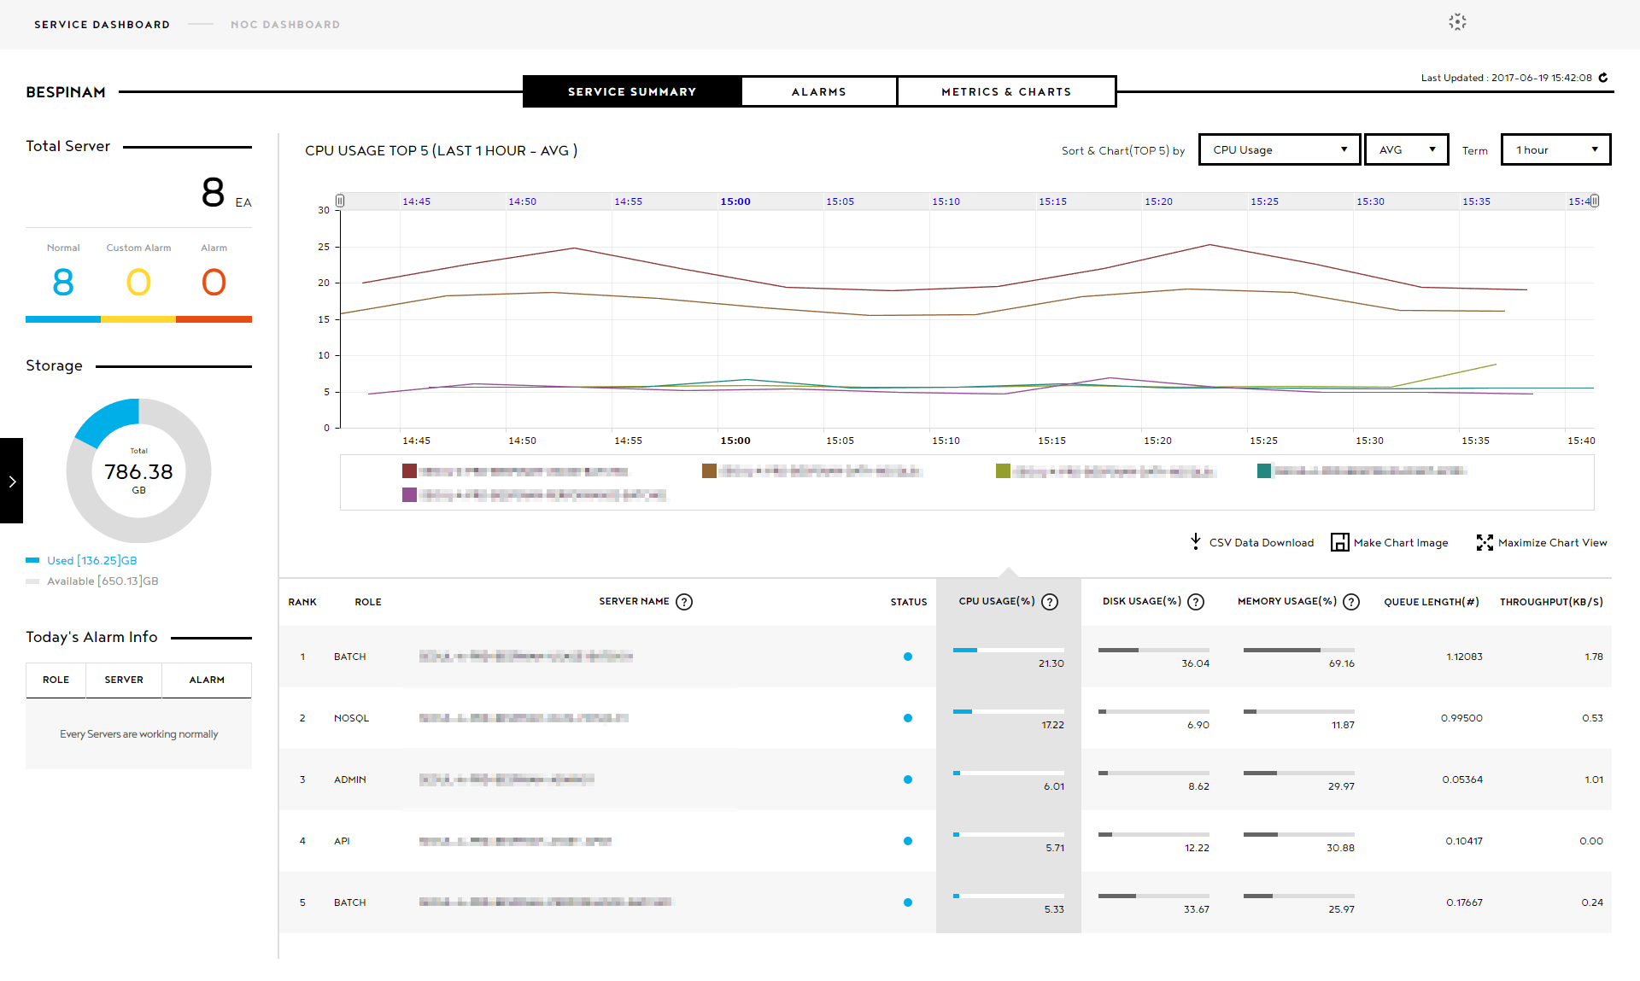

* + 1. Total Server

The number of servers and incurred alarm summary are vividly indicated with highly recognizable colors.

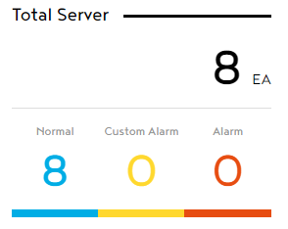

* + 1. Disc Storage

Be aware of the server storage (disc) and its current usage, and manage it.

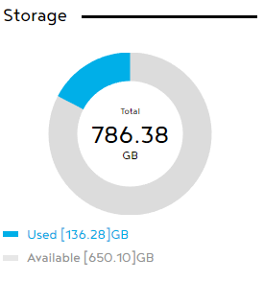

* + 1. Today’s Alarm Info

Shows the server and other relevant information of the alarms that incurred on the day for an immediate check.

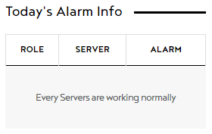

* + 1. Change trend of top 5 servers

You can review the change trend of the top 5 servers in usage per CPU, Memory, Disk, Queue, and Throughput; you can easily set the order sequence and collection term depending on your interest.

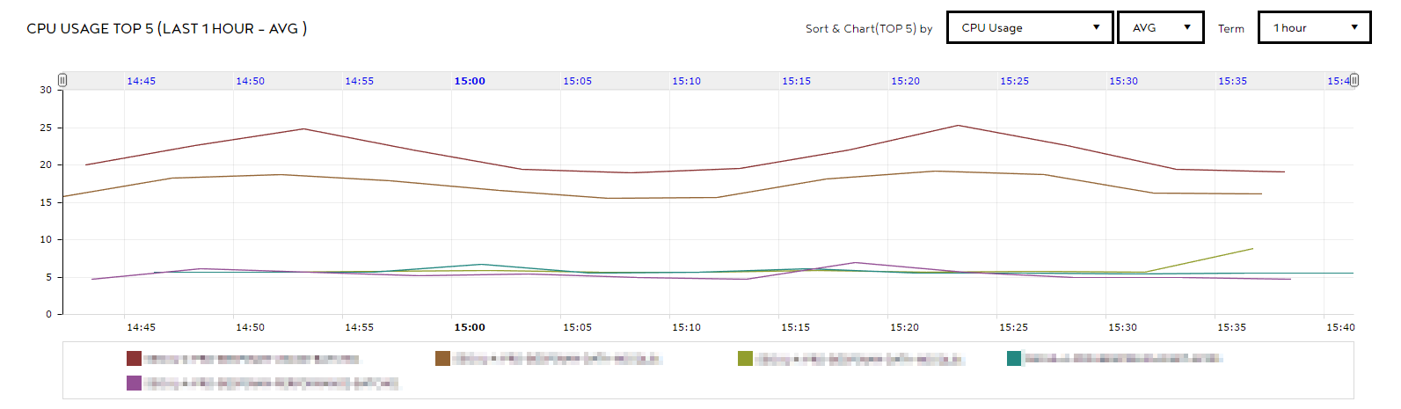

* + 1. Performance status of the top 5 servers

Based on the selected index among 5 main indexes, you can monitor the performance status of the top 5 servers.

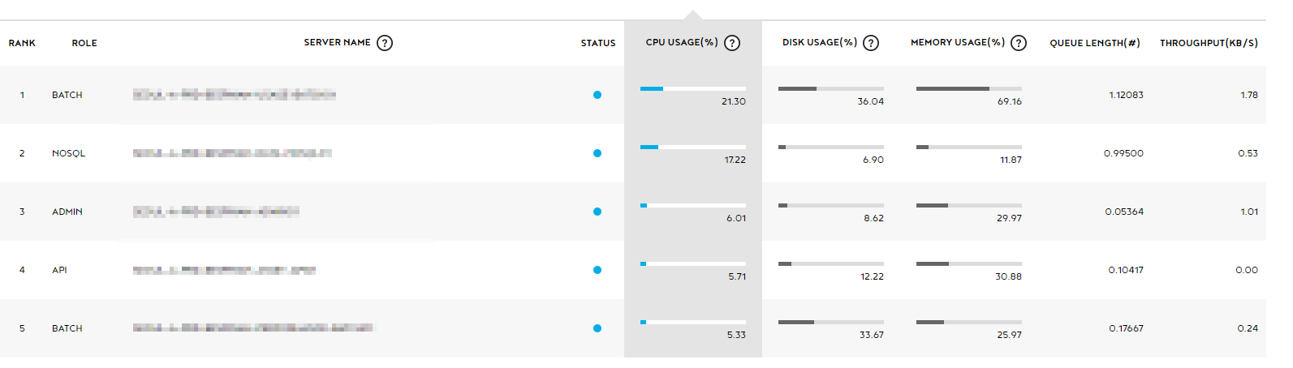

* 1. Alarms

You can search the incurred alarm summary per day or term. It provides metric information based on the incurred time for the progress status of the incurred/stopped alarms and its cause analysis.

Monitoring Dashboard > Service Dashboard > Alarm

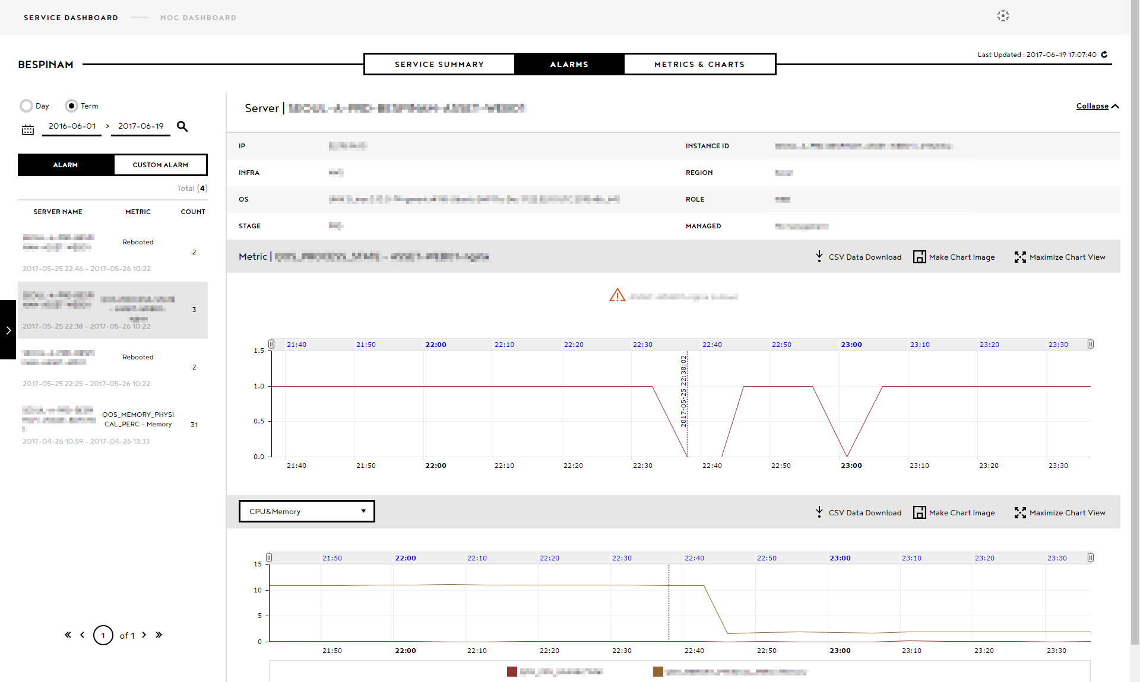

* + 1. Alarm List

Shows the alarm list, where you can easily search for the alarm progress status per day or term. Opened alarms and custom alarms are indicated in a different color in the background.

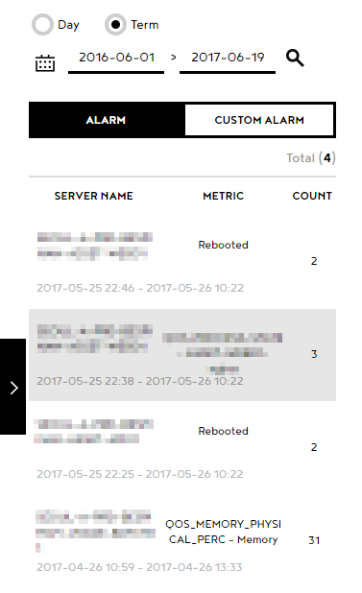

* + 1. Alarm Info

Provides the details of the server where the alarm incurred

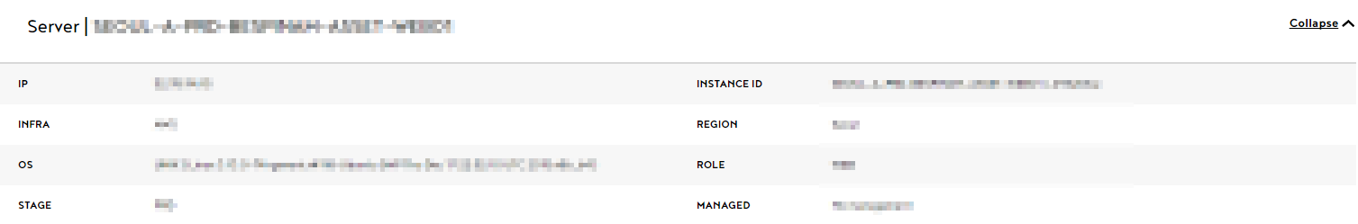

* + 1. Metric Alarm Chart

Shows the metric alarm that incurs in a server. You can review the server conditions.

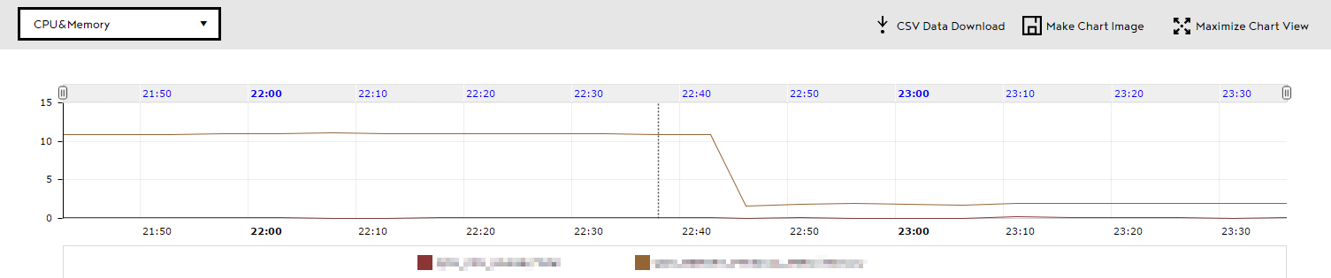

* + 1. QoS Alarm Chart

You can see the usage for each CPU & Memory, Disk, Throughput, and Queue Length of the server per hour, to check the hour with the most and least usage. It also provides necessary information for adjusting the scale.

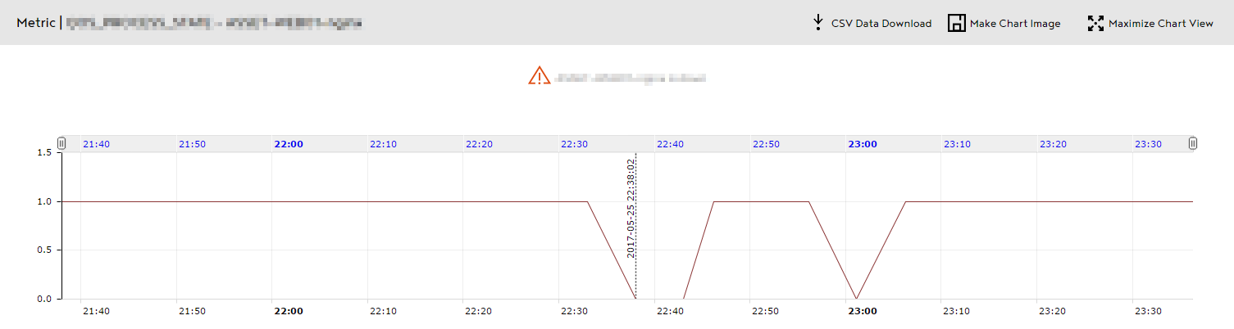

* 1. Metrics & Charts
     1. Server

You can see the usage of CPU / Memory / Disk / Queue / Network in graphs, by setting the term per server for each service.

You can check all 5 performances in a graph, or select and enlarge a graph.

Monitoring Dashboard > Service Dashboard > Metrics & Charts > Server

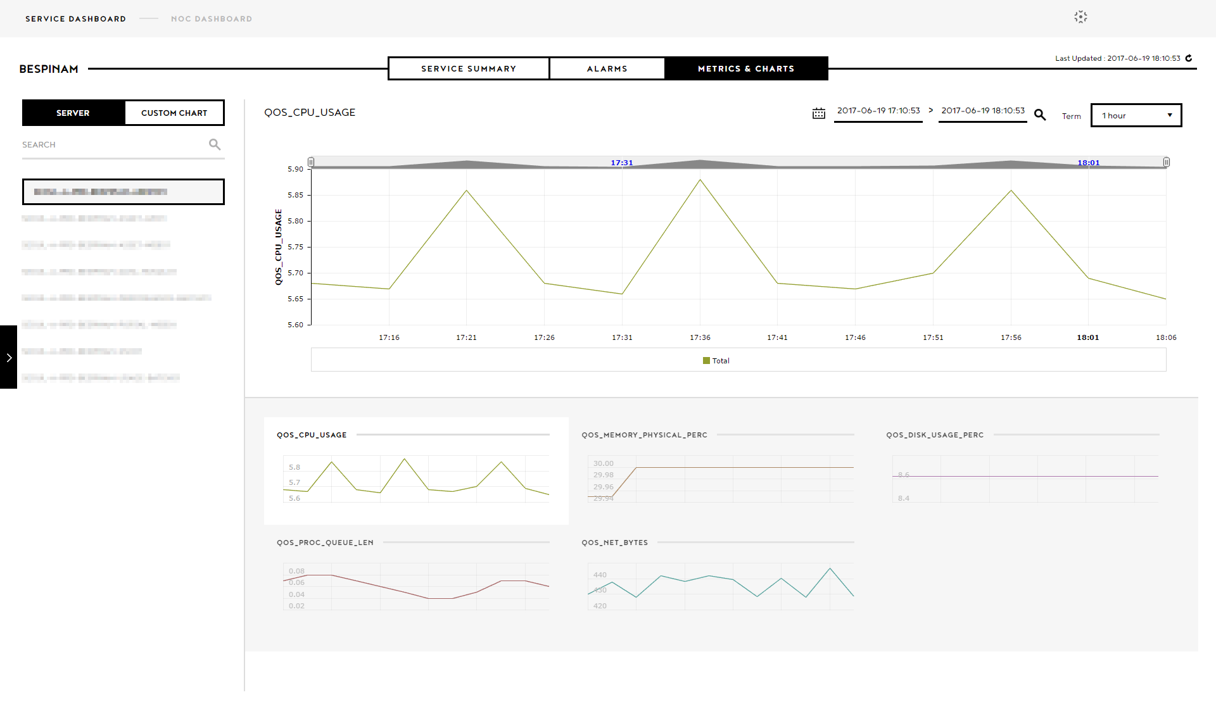

* + - 1. Server List

You can check and search the list of each server. If you select a server, you can see the main five metrics in a graph.

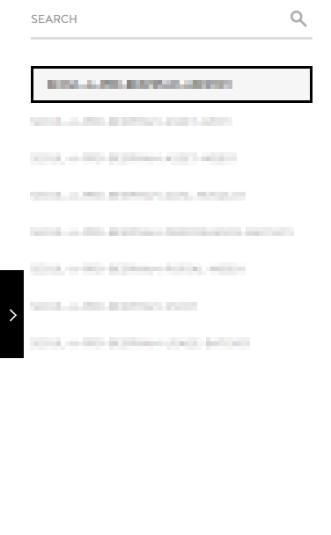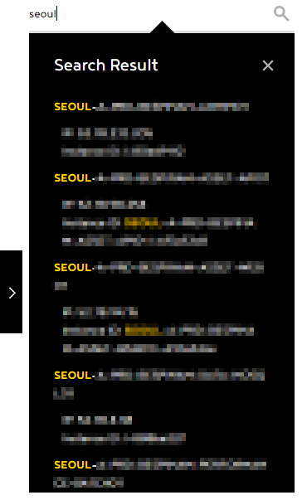

* + - 1. Metric Chart

You can set the term to intuitively understand the overall status of 5 main metrics; or you can select one metric to check it in a detailed graph from an enlarged chart.

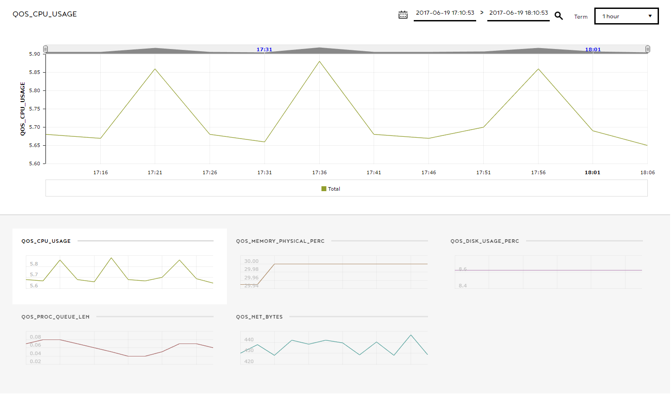

* + 1. Custom Chart

You can select servers and metrics of your interest to check their metric information in graphs.

Monitoring Dashboard > Service Dashboard > Metrics & Charts > Custom Chart

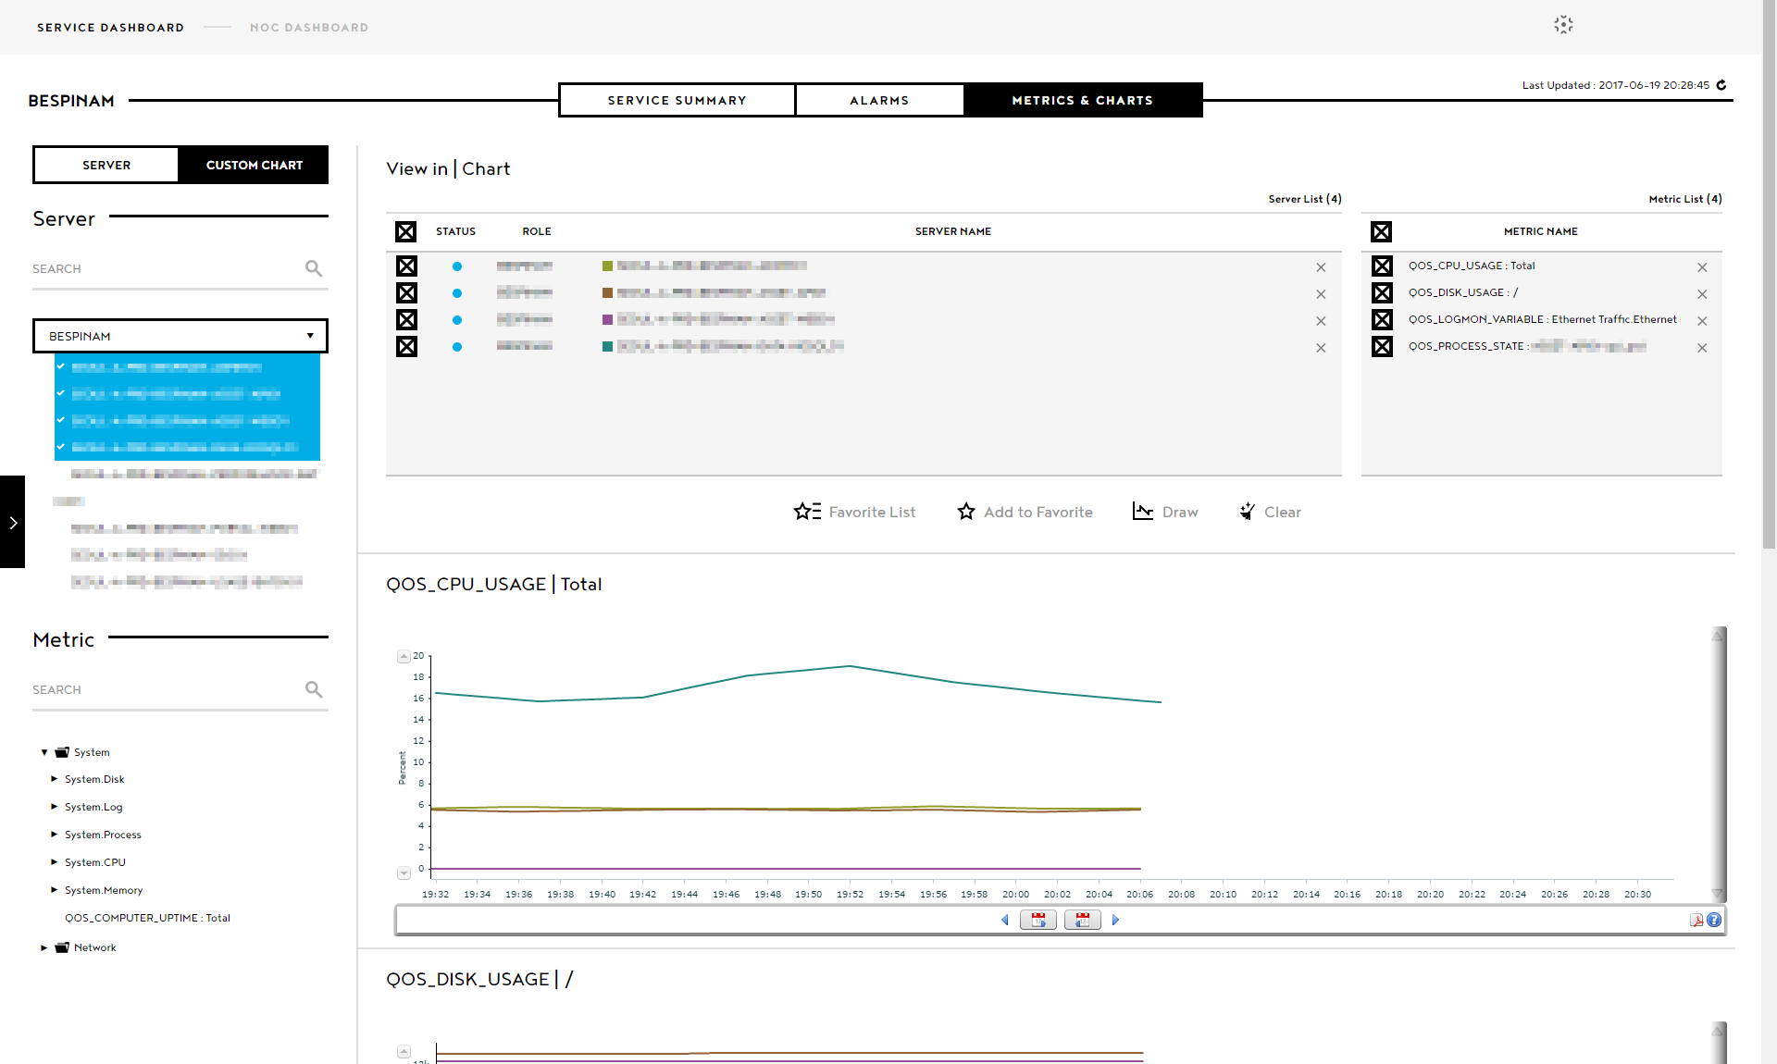

* + - 1. Server & Metric List

You can check and search server lists and metric lists that you can select to see in a chart.

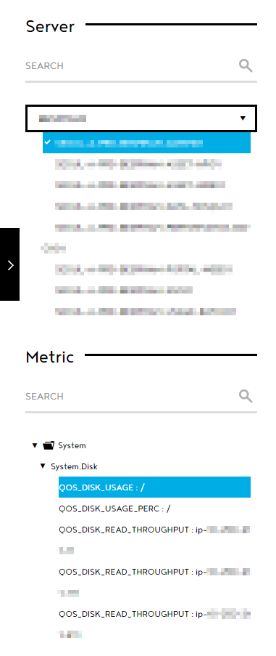 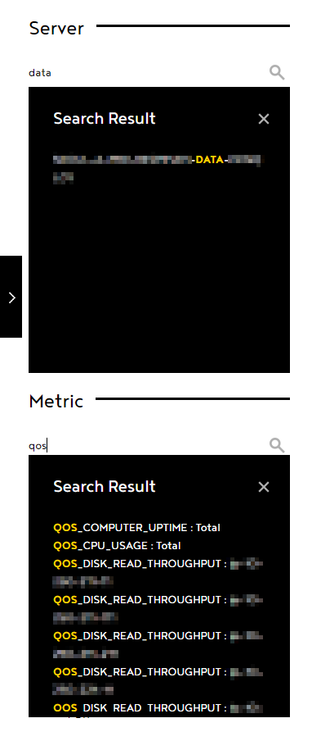

* + - 1. View in | Chart

Click “View in Chart” to check the chart for each metric of the servers you have set.

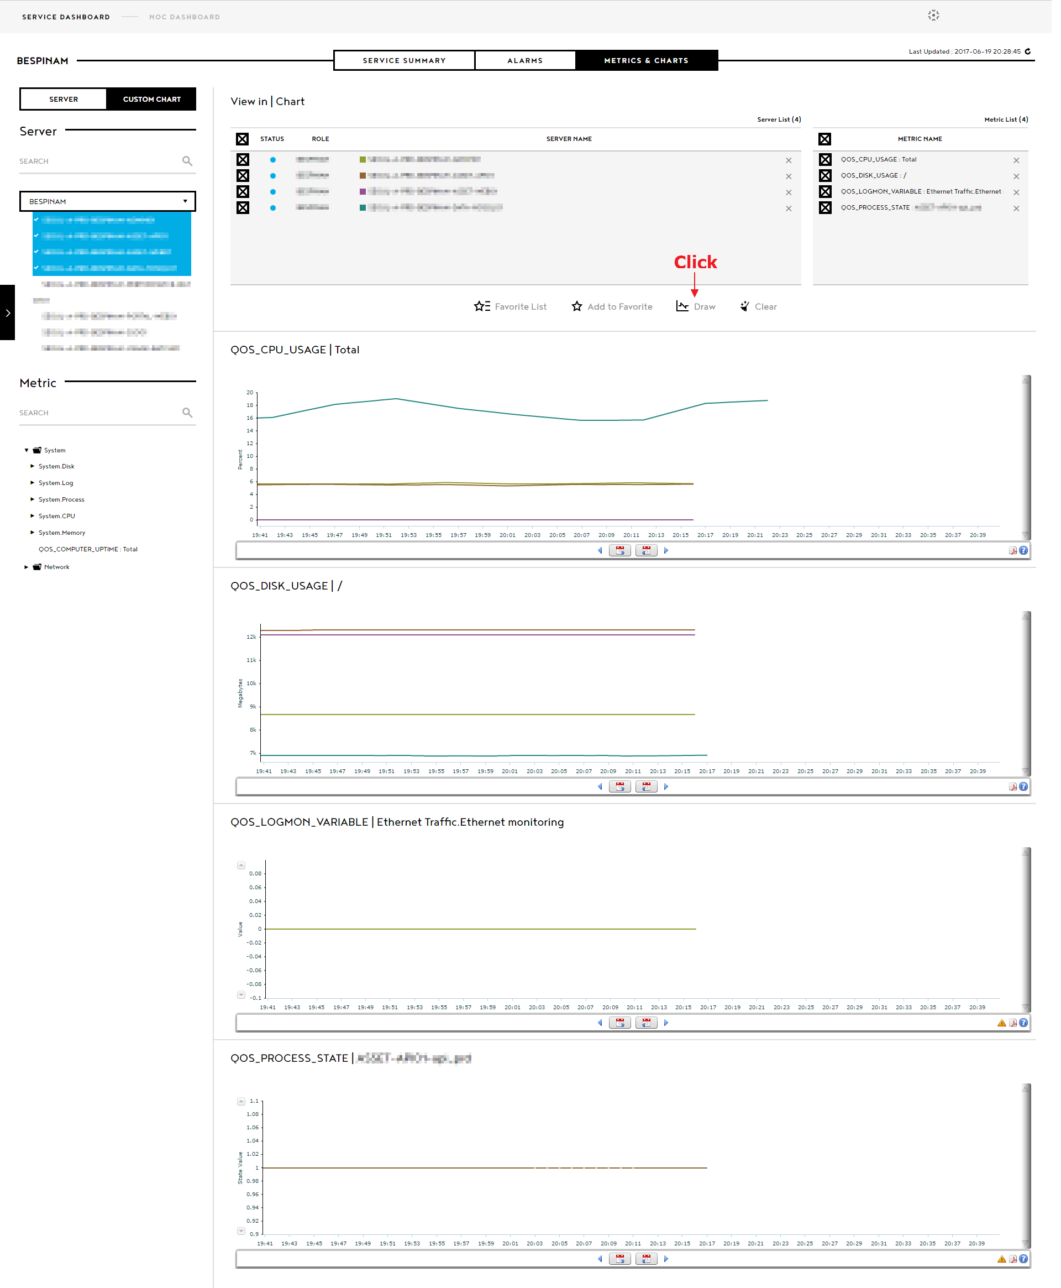

* + - 1. Favorites

You can create and manage custom charts with Favorites.

* + - * 1. Add to Favorites

When you click “Add to Favorites”, an “Add to Favorites” pop-up appears. Its default name is “Favorite Date”.

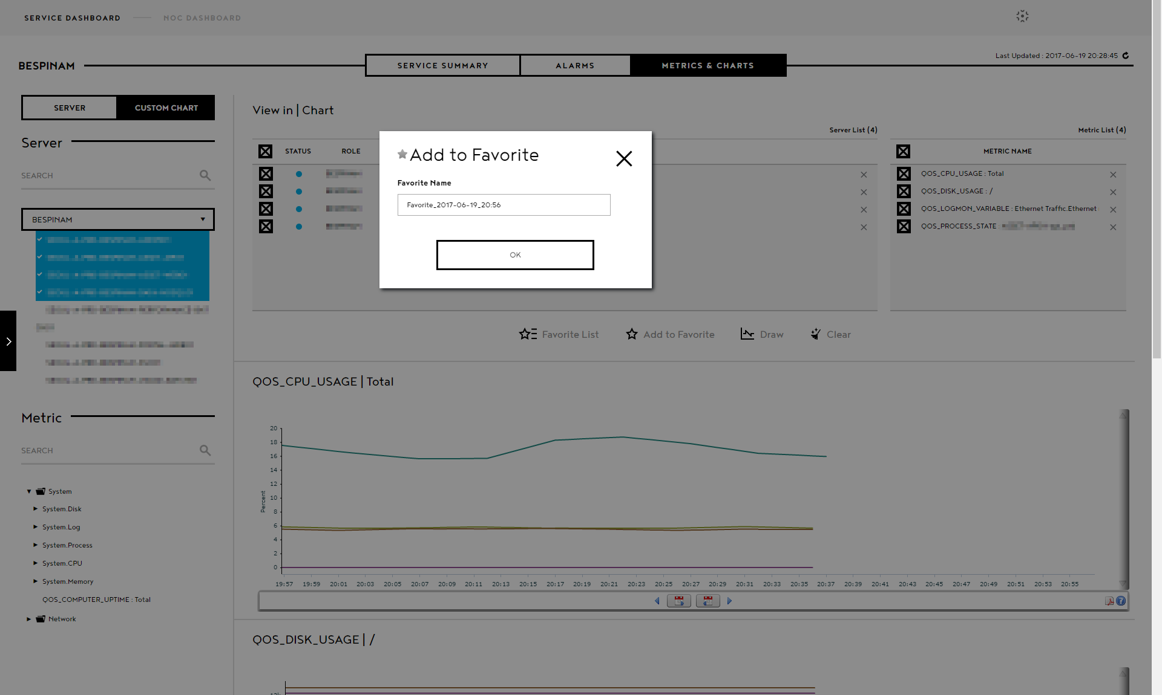

* + - * 1. Favorite List

If you have added to favorites, you can check it on the “Favorites” list pop-up and import it.

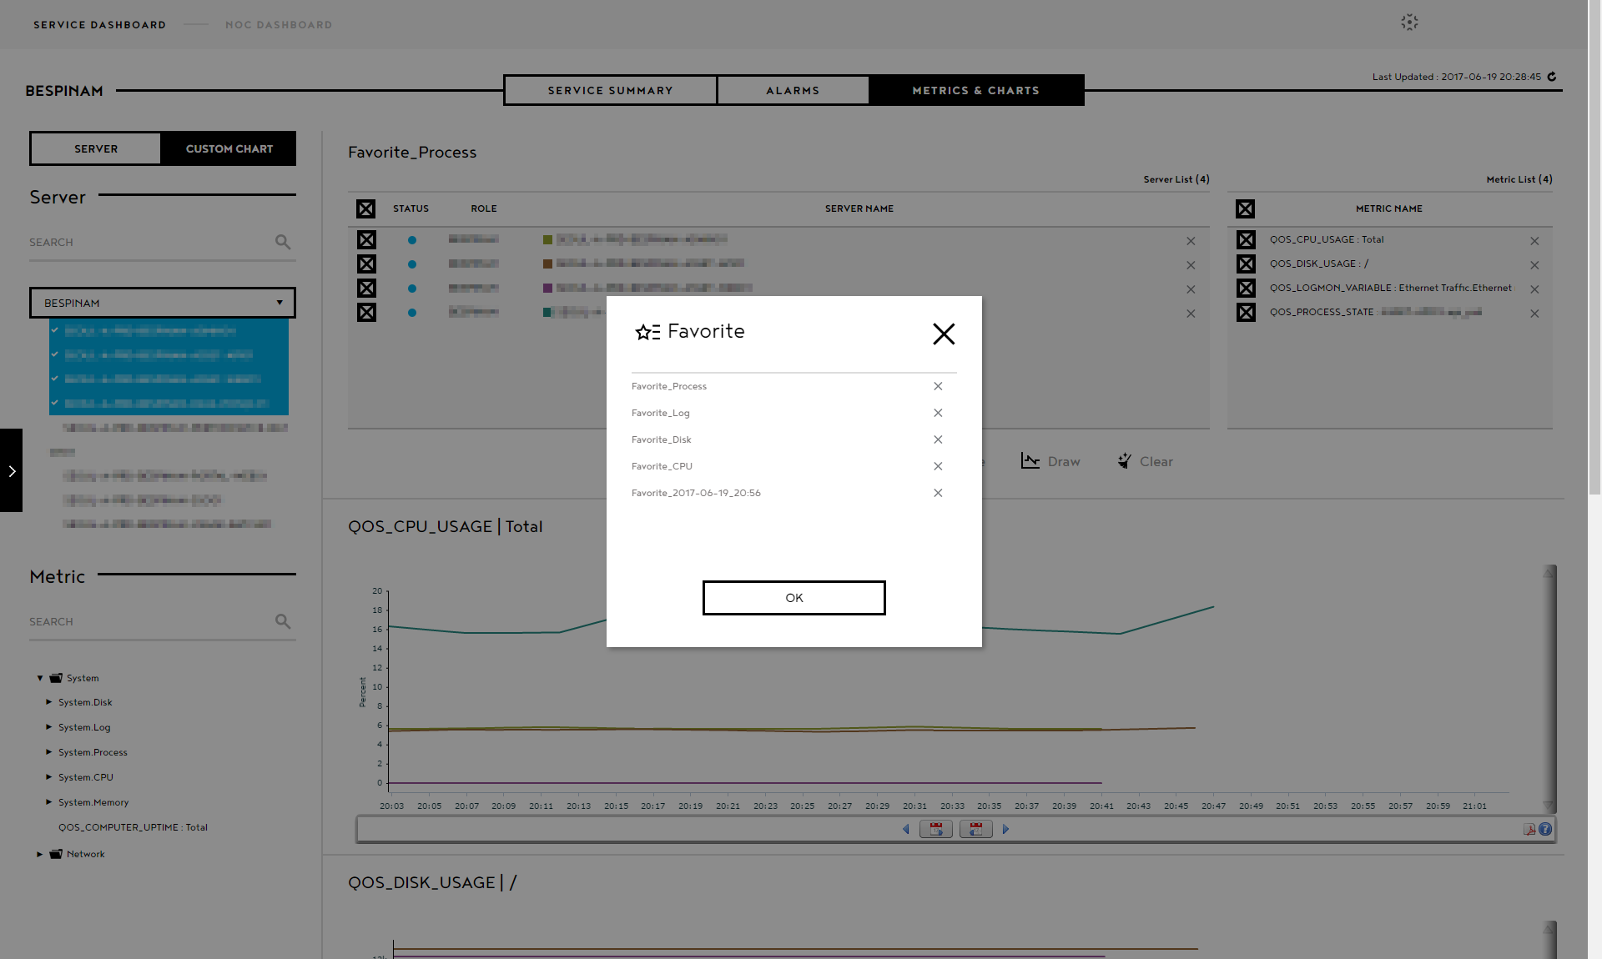

1. NOC Dashboard
   1. Service Group

The status of each service is shown live.

When an alarm incurs in a service, the red circle before the service title is lit. When there are many alarms, the size of the circle gets bigger.

You can check the summary of the alarms on Dashboard immediately.

Monitoring Dashboard > NOC Dashboard > Service Group

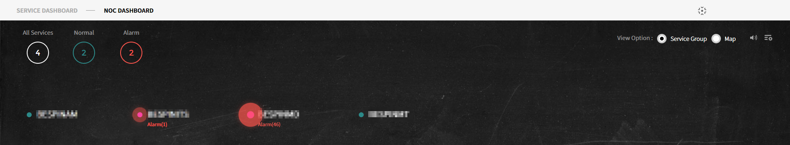

* + 1. Alarm List

Click the service where the alarm incurred to check the alarm details of the relevant service.

When you select the alarm, the available chart is shown depending on the alarm type when possible.

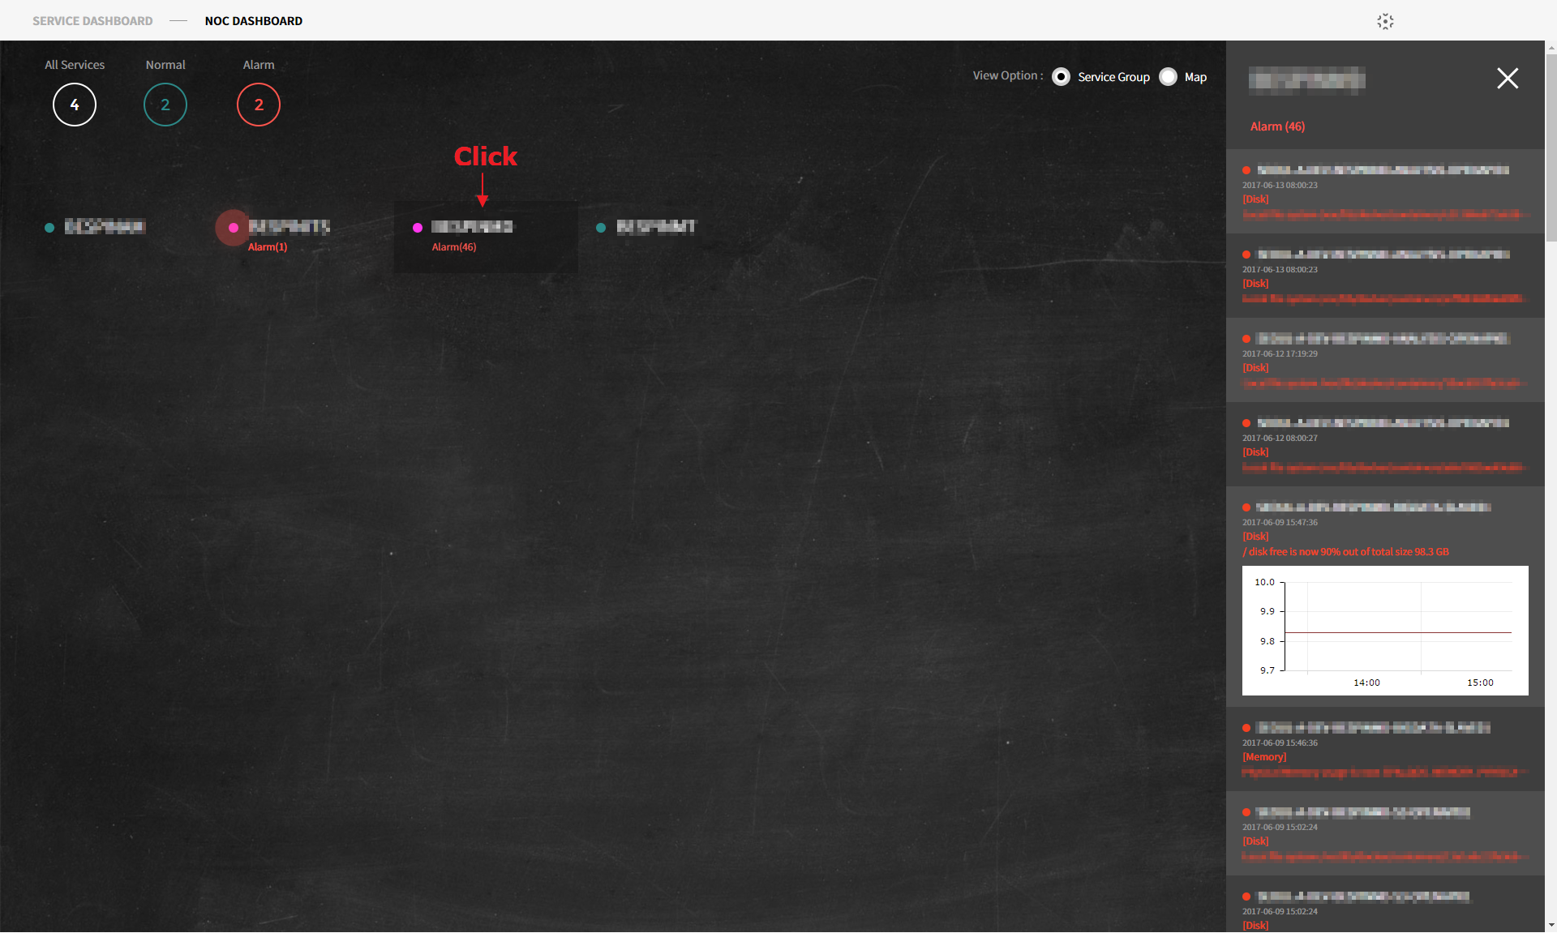

* + 1. Monitoring Service Group List

The monitoring service group list pop-up appears when you click the configuration icon.

You can select the services to be shown on the Dashboard by checking the boxes.

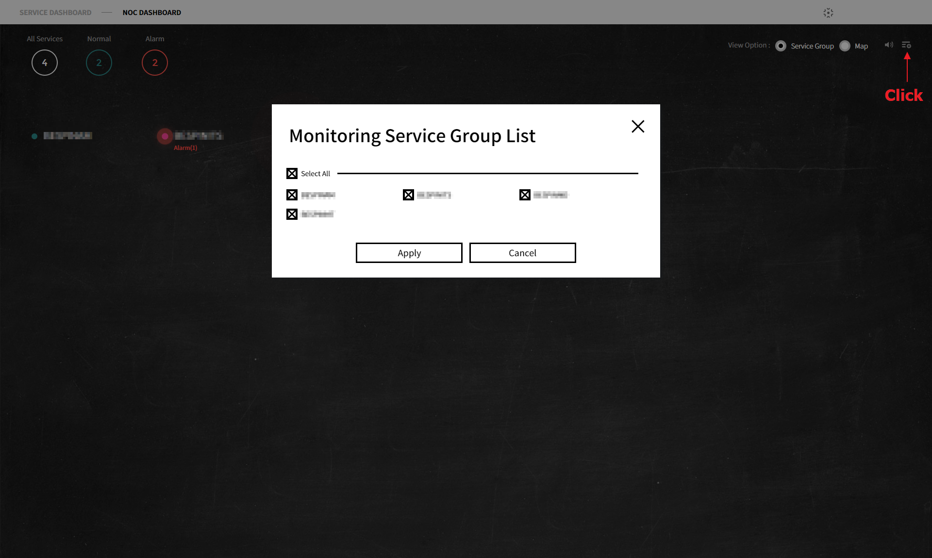

* 1. Map

Provides Geographic NOC Dashboard. You can monitor Hybrid CLOUD and all Infrastructures by region in a single pane.

When alarms incur, a red circle will be shown on the vertex of the region. When there are many alarms, the circle gets bigger.

Monitoring Dashboard > NOC Dashboard > Map

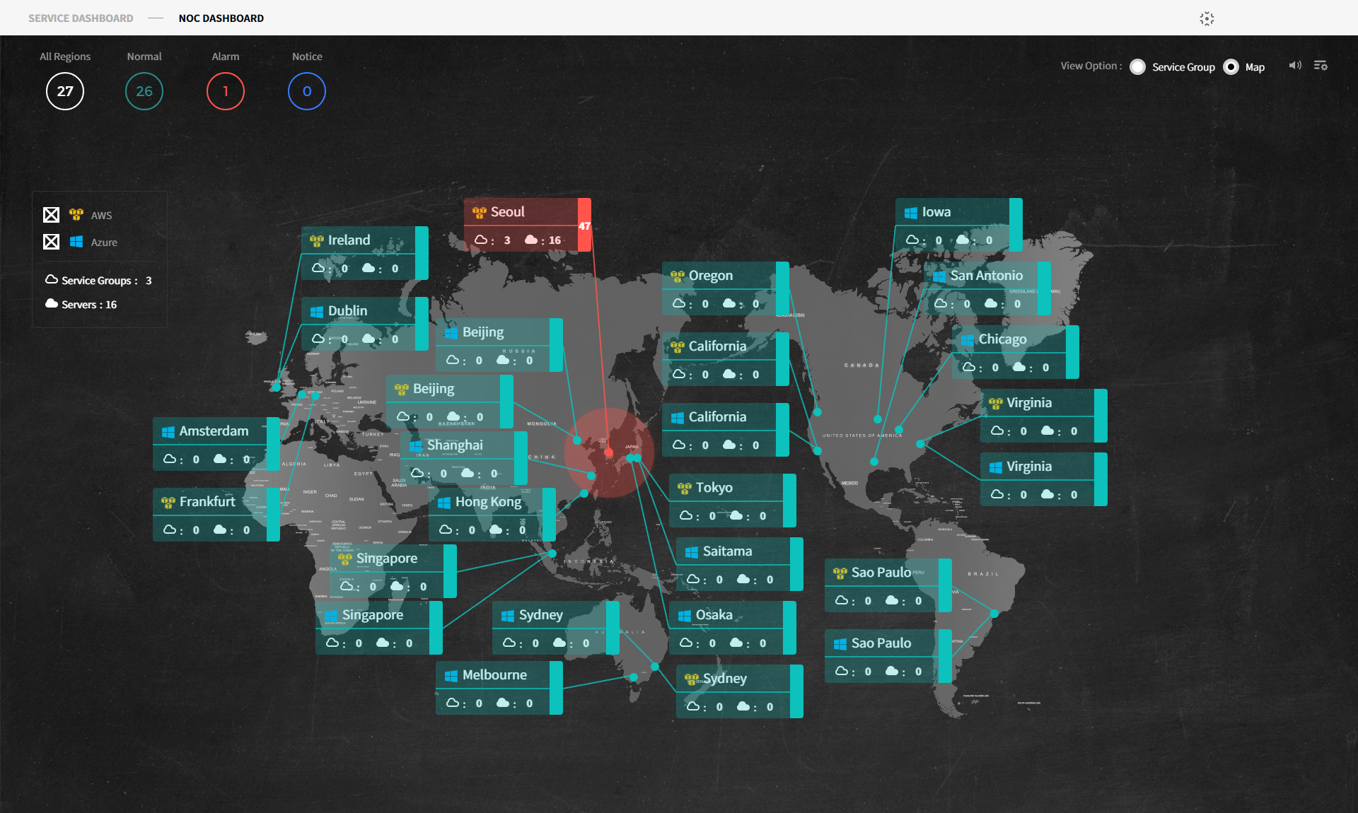

* + 1. Alarm List

Click the region where alarms incurred to check the alarm details per service group in the relevant region.

When you select the alarm, the available chart is shown depending on the alarm type when possible.

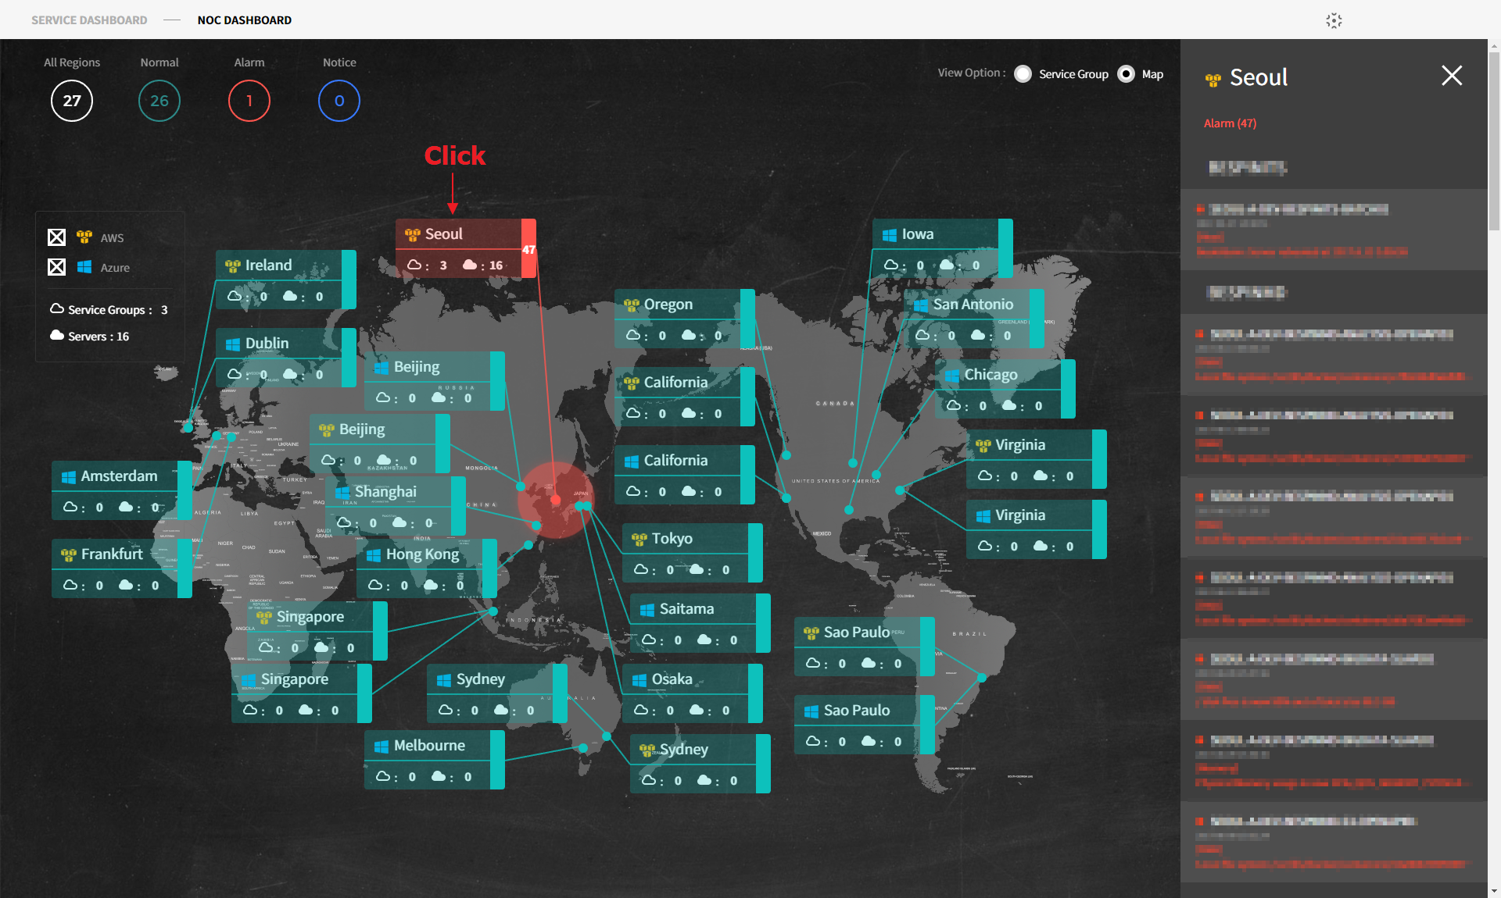

* + 1. Monitoring Region List

Click the configuration icon and the monitoring region list pop-up appears.

You can select the regions to be shown on the Dashboard by checking the checkboxes.

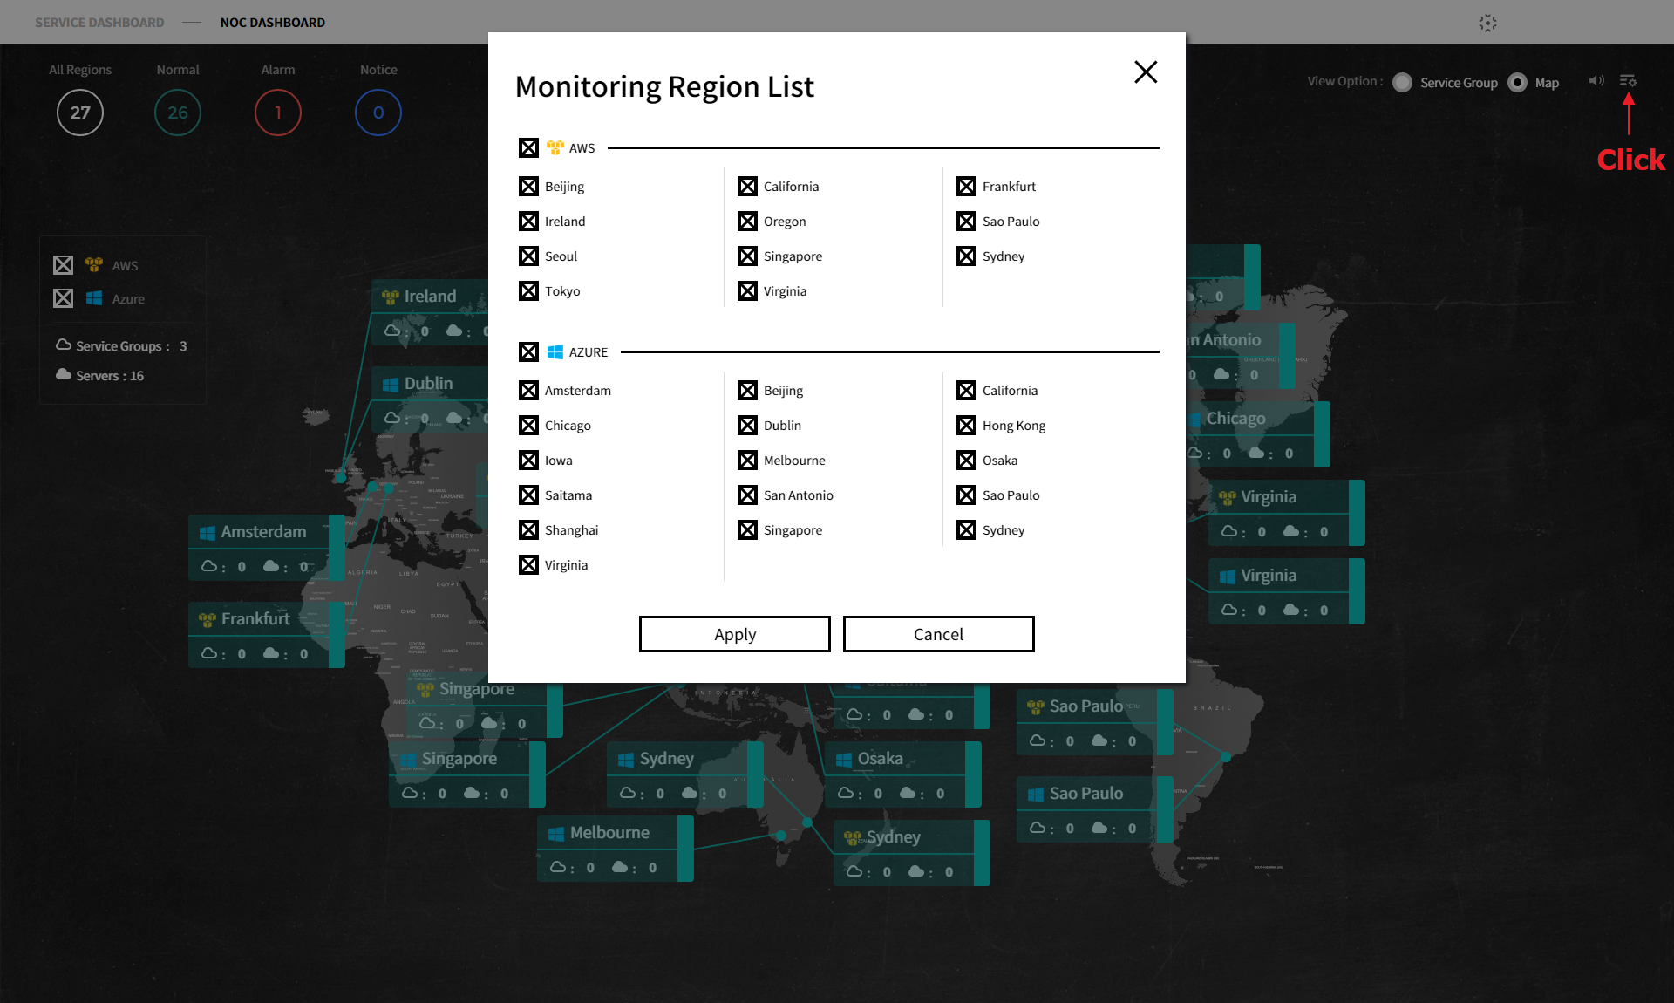

1. Administrator
   1. User Management
      1. User Setting

Search monitoring dashboard’s user information or set roles in user setting.

Monitoring Dashboard > Administrator > User Setting

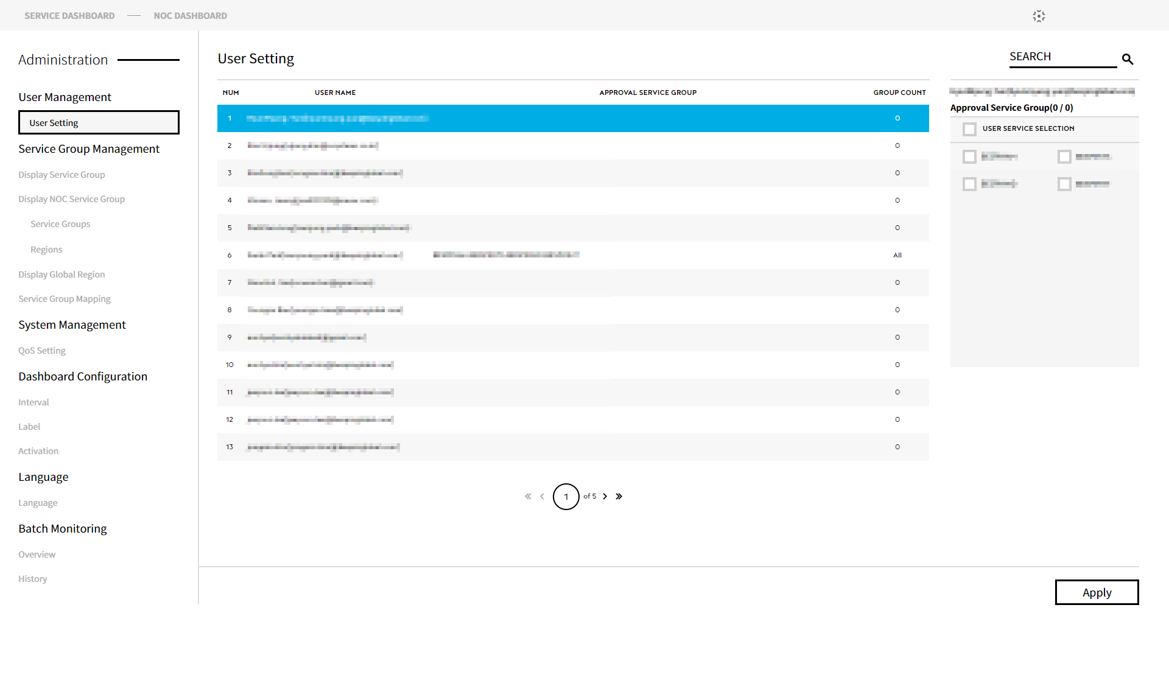

* + - 1. Approval Service Group

Set the services the selected users from the list can access by checking the checkboxes.

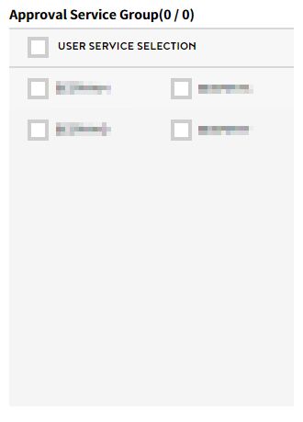

* 1. Service Group Management
     1. Display Service Group

Among the services set as monitoring groups in service group mapping, you can set the services to expose on Service Dashboard.

Monitoring Dashboard > Administrator > Service Group Management > Display Service Group

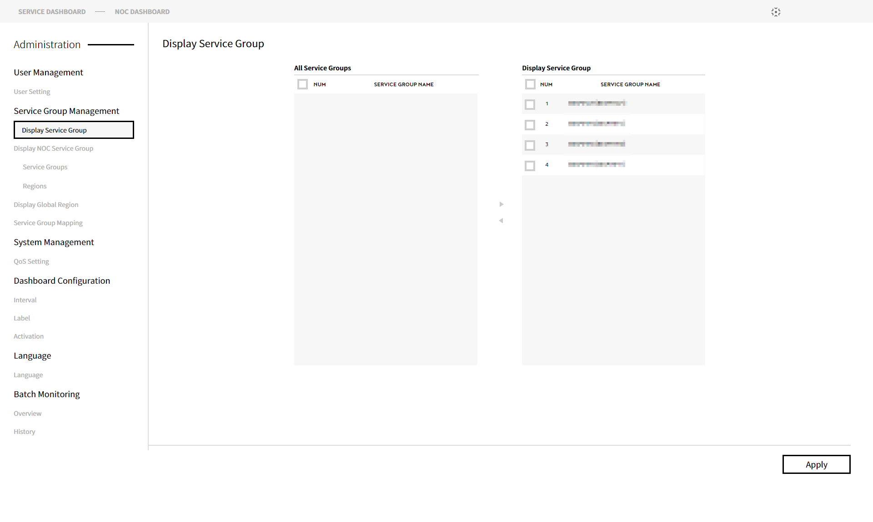

* + 1. Display NOC Service Group
       1. NOC Service Groups (Service Groups)

Among the services set as monitoring groups in service group mapping, you can set the services to expose on NOC Dashboard.

Monitoring Dashboard > Administrator > Service Group Management > Display NOC Service Group > Service Groups

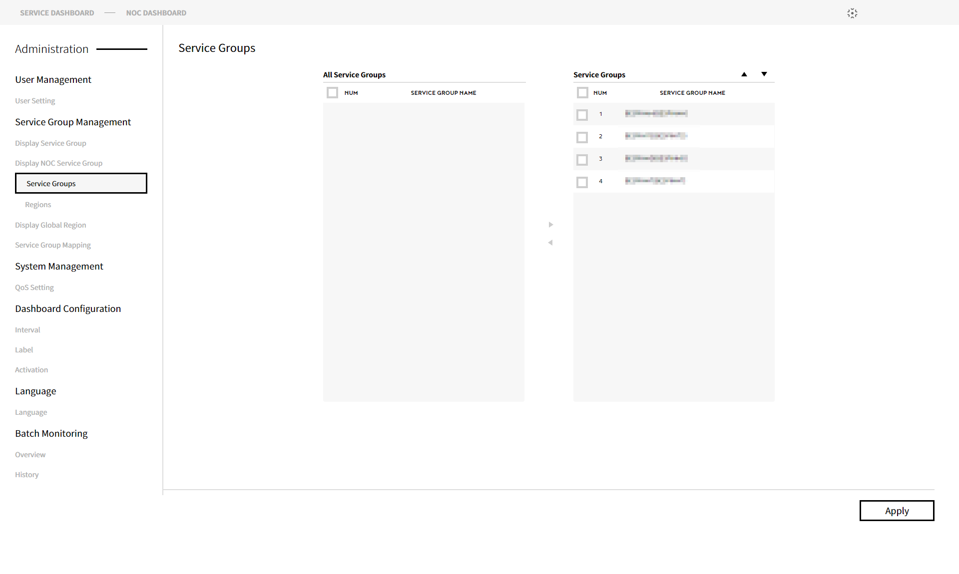

* + - 1. NOC Region List (Regions)

Among the regions selected as an NOC region list from the common region list, you can set the regions to expose on NOC Dashboard.

Monitoring Dashboard > Administrator > Service Group Management > Display NOC Service Group > Regions

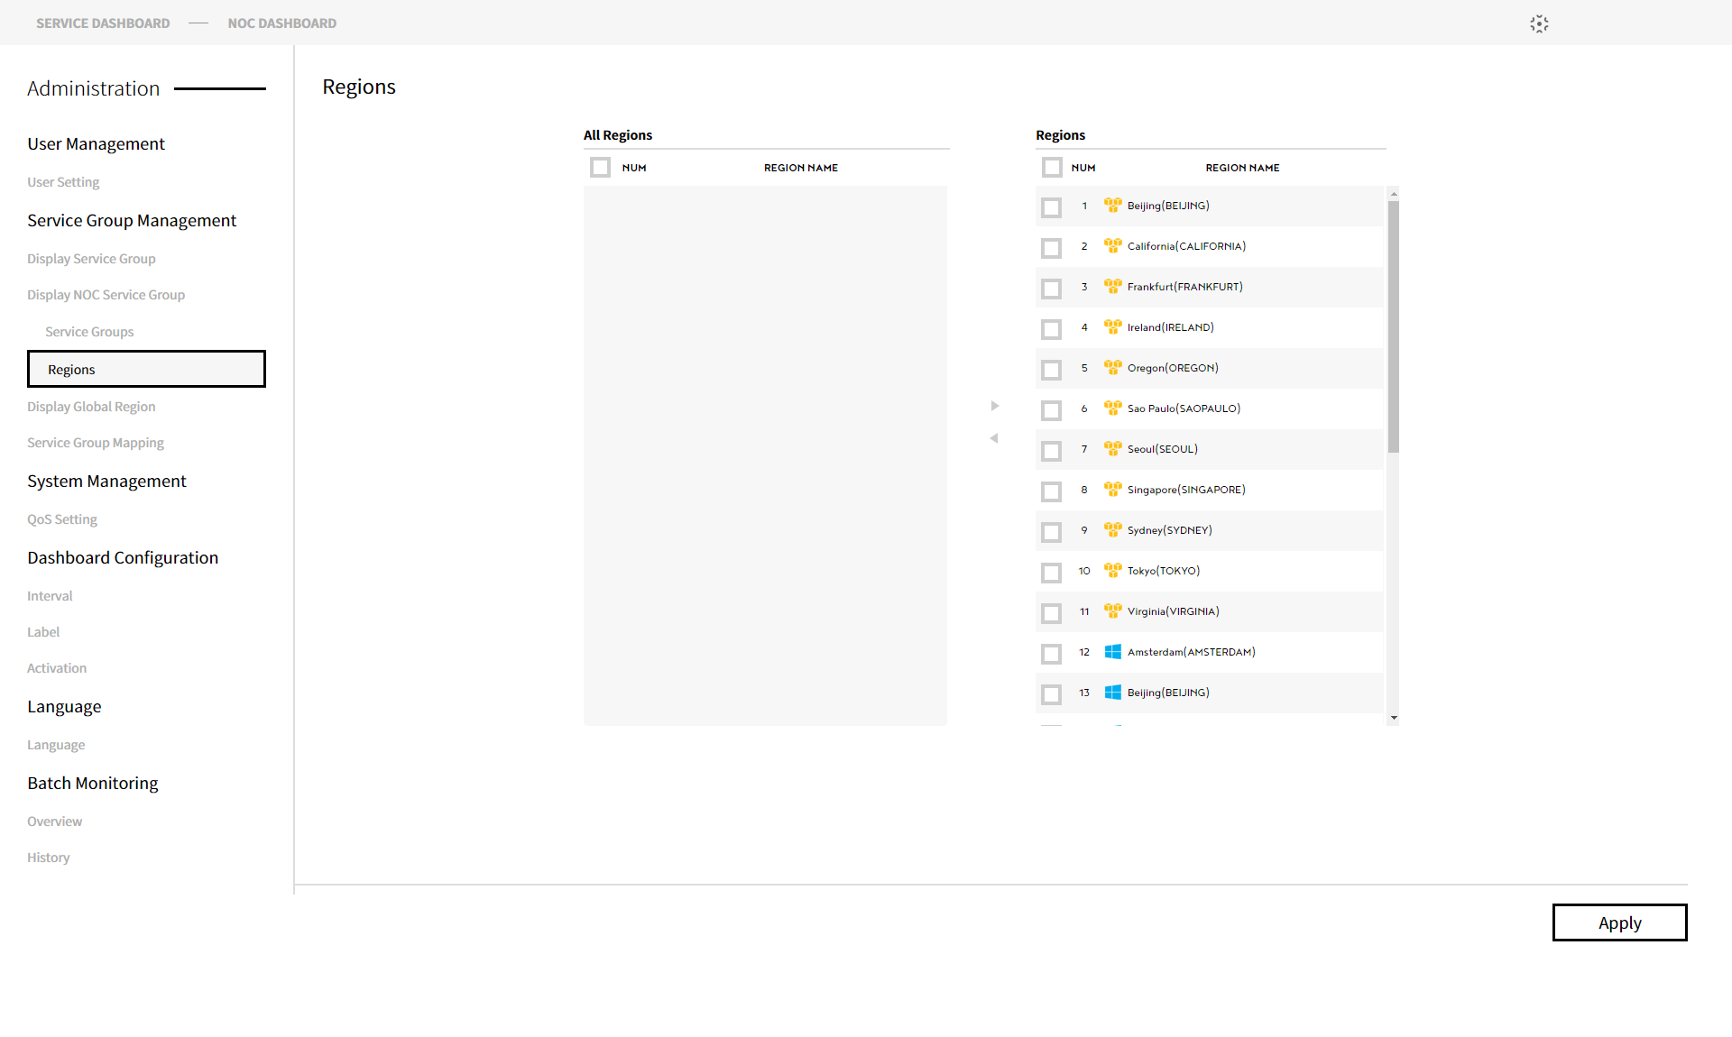

* + 1. Common Region List (Display Global Region)

Among the regions registered in the system, you can set the regions to be used on NOC Region List.

Monitoring Dashboard > Administrator > Service Group Management > Display Global Region

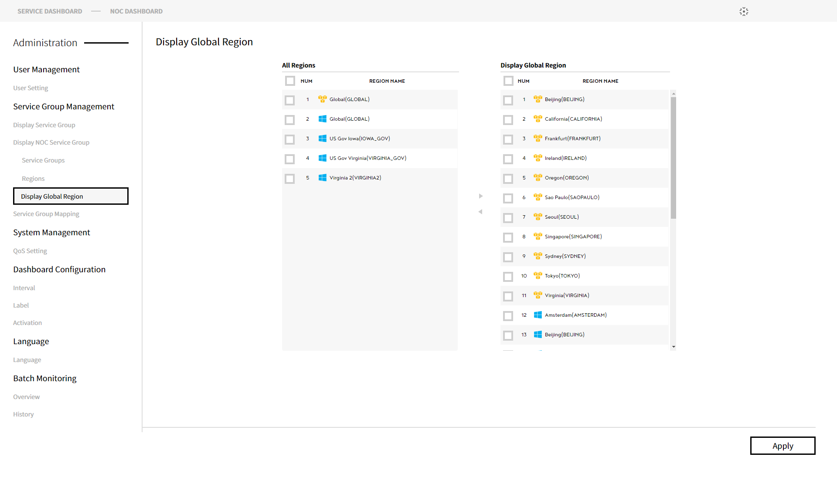

* + 1. Service Group Mapping

Among the services registered as service groups, you can map the service groups to be used as a monitoring group.

Monitoring Dashboard > Administrator > Service Group Management > Service Group Mapping

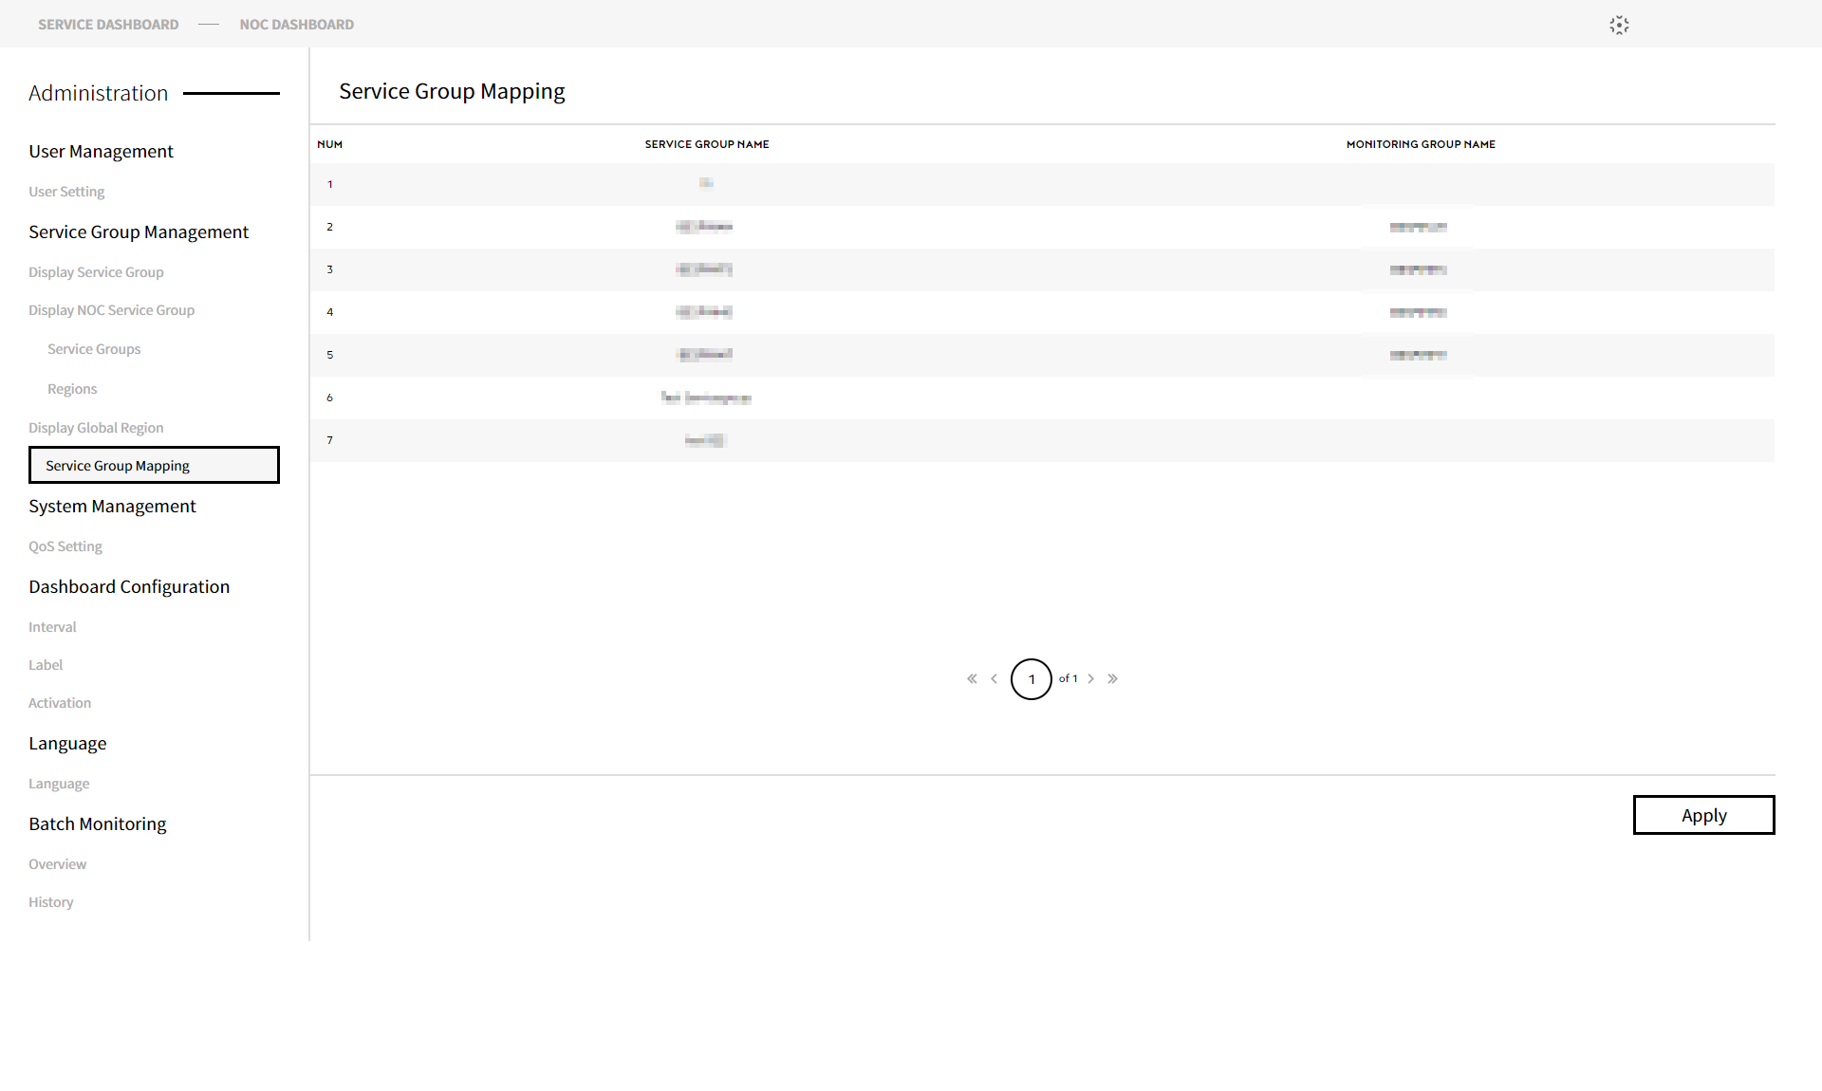

* 1. System Management
     1. QoS Setting

You can see the details of the items registered as QoS.

Monitoring Dashboard > Administrator > System Management > QoS Setting

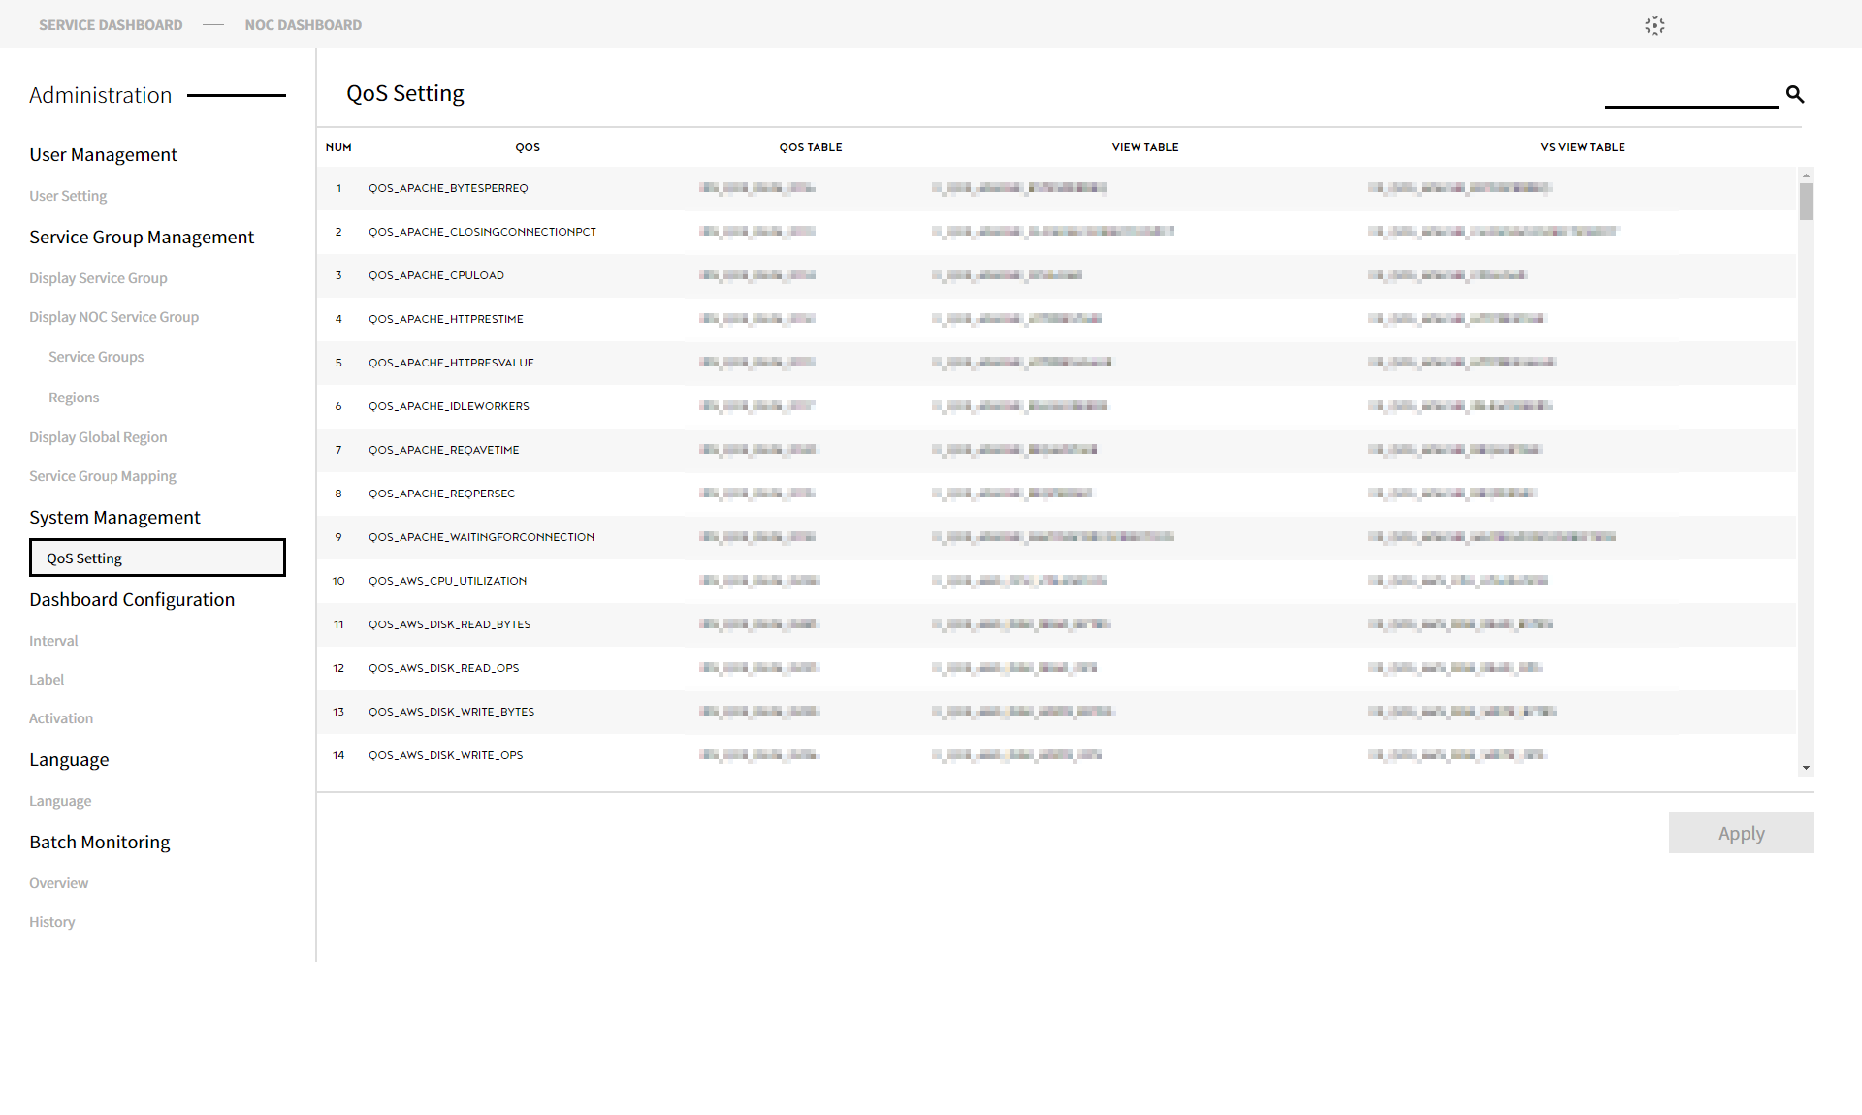

* 1. Dashboard Configuration
     1. Interval

Set the cycle of dashboard items on Interval pane.

Monitoring Dashboard > Administrator > Dashboard Configuration > Interval

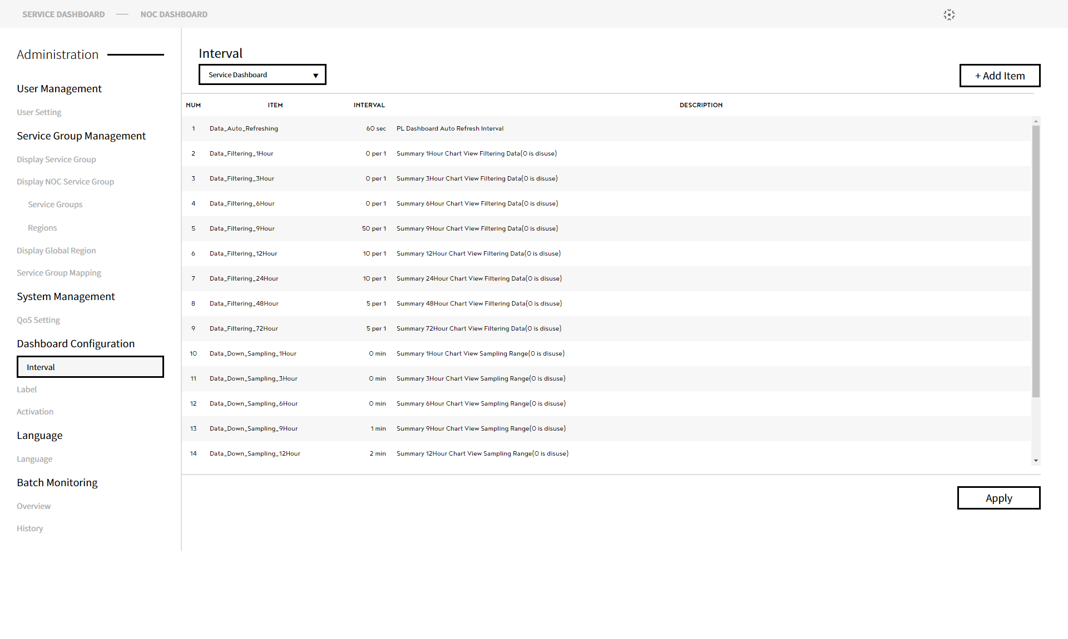

* + 1. Label

Manage words and phrases that are used on Dashboard on Label pane.

Monitoring Dashboard > Administrator > Dashboard Configuration > Label

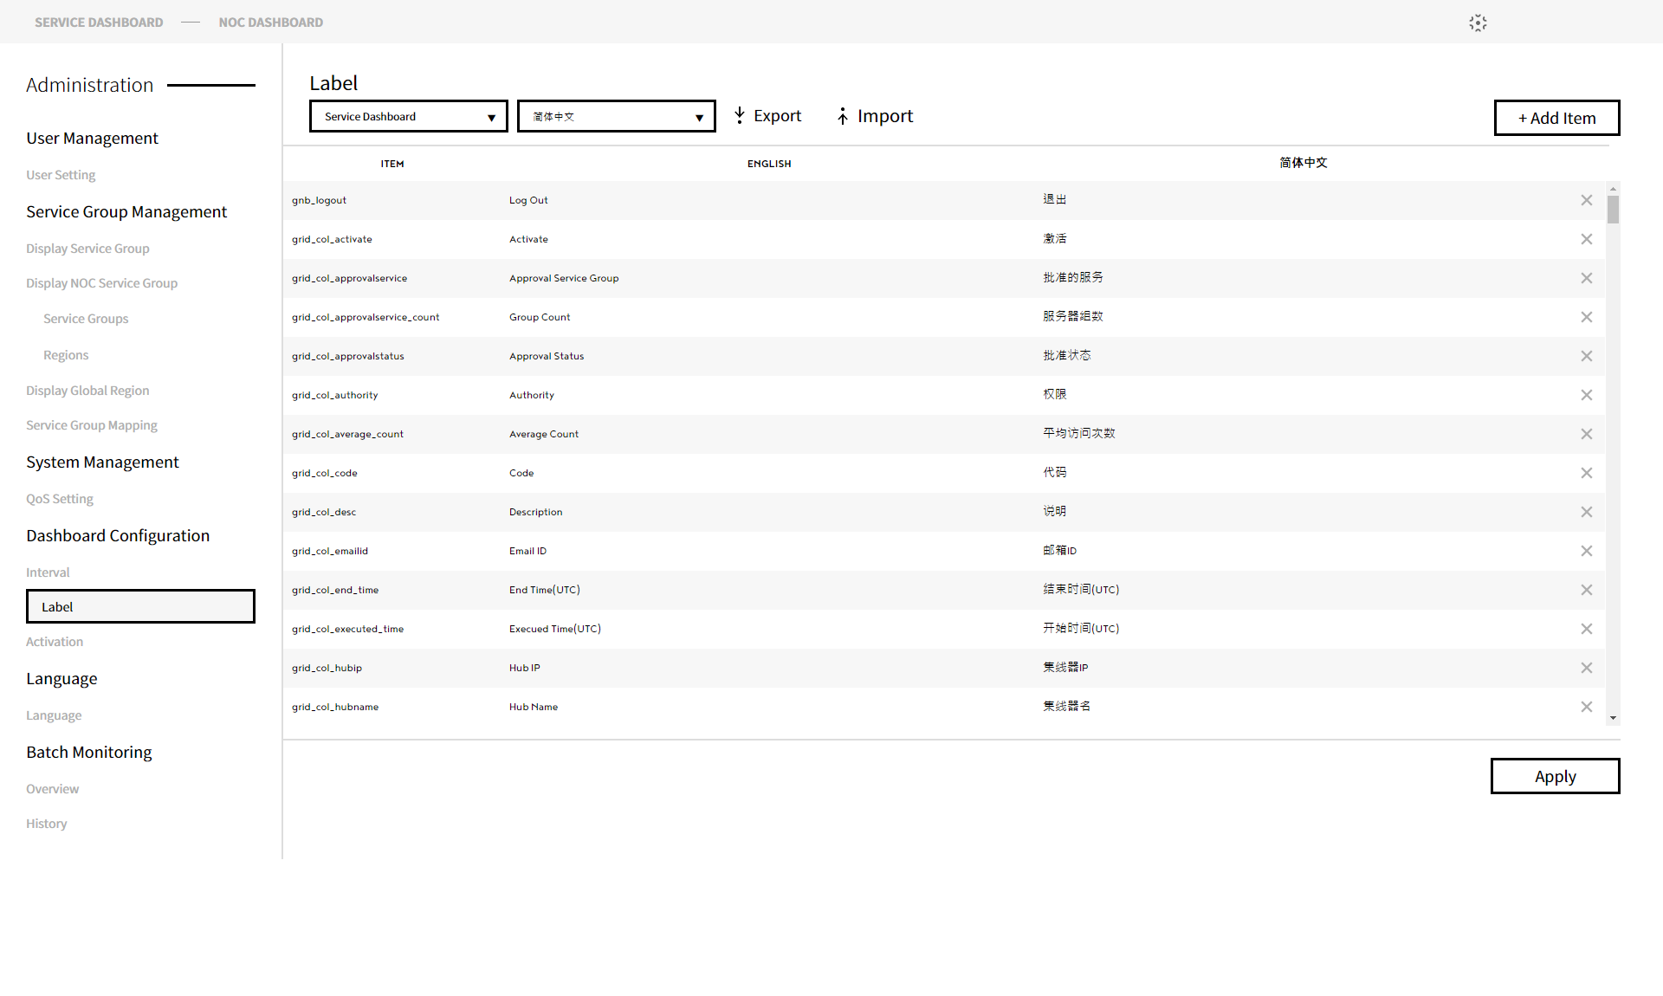

* + 1. Activation

You can activate or deactivate some features of Dashboard on Activation pane.

Monitoring Dashboard > Administrator > Dashboard Configuration > Activation

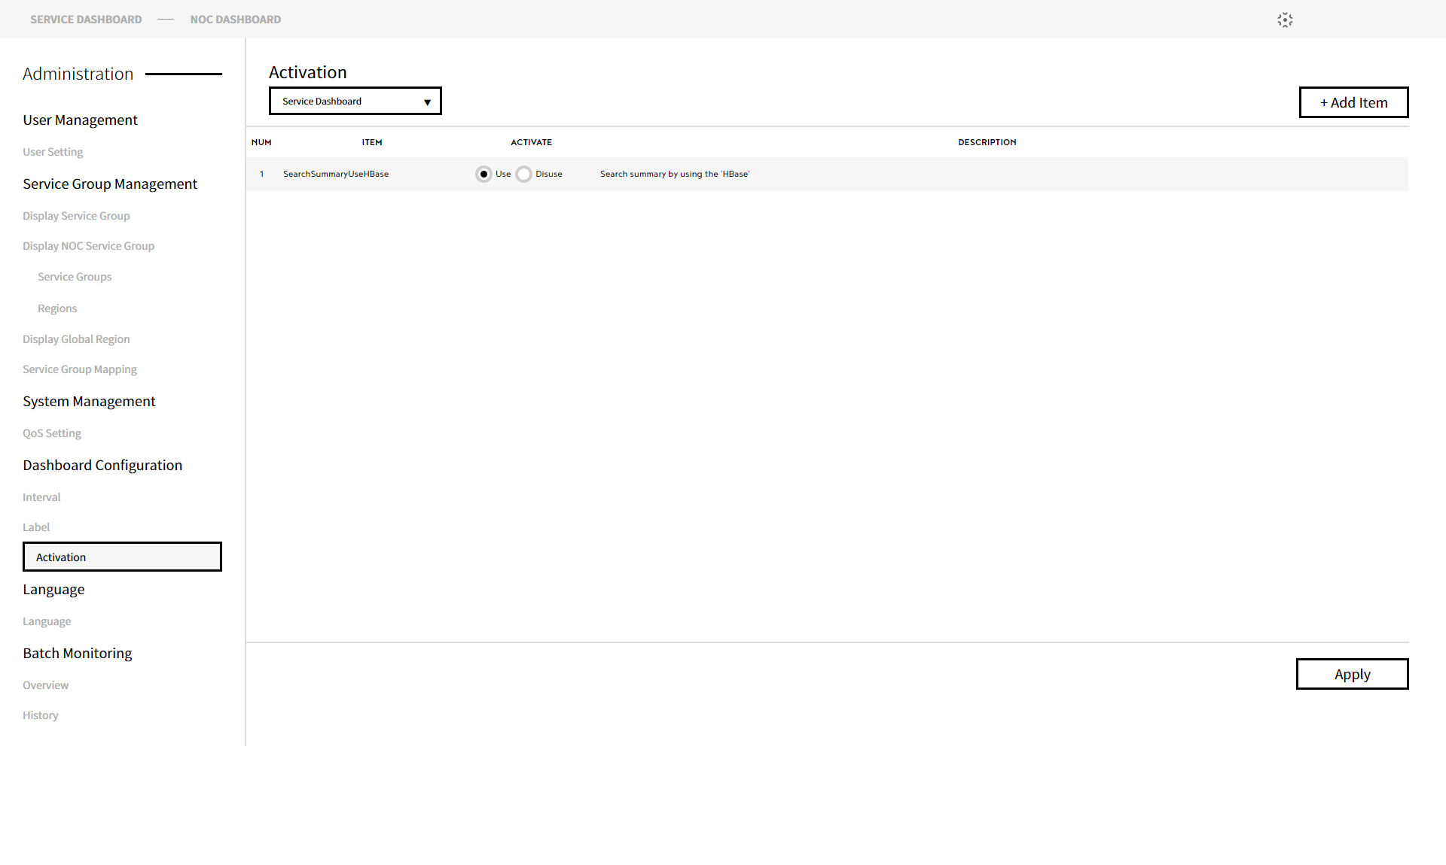

* 1. Language
     1. Language

Set the language to use on Monitoring Dashboard.

Monitoring Dashboard > Administrator > Language > Language

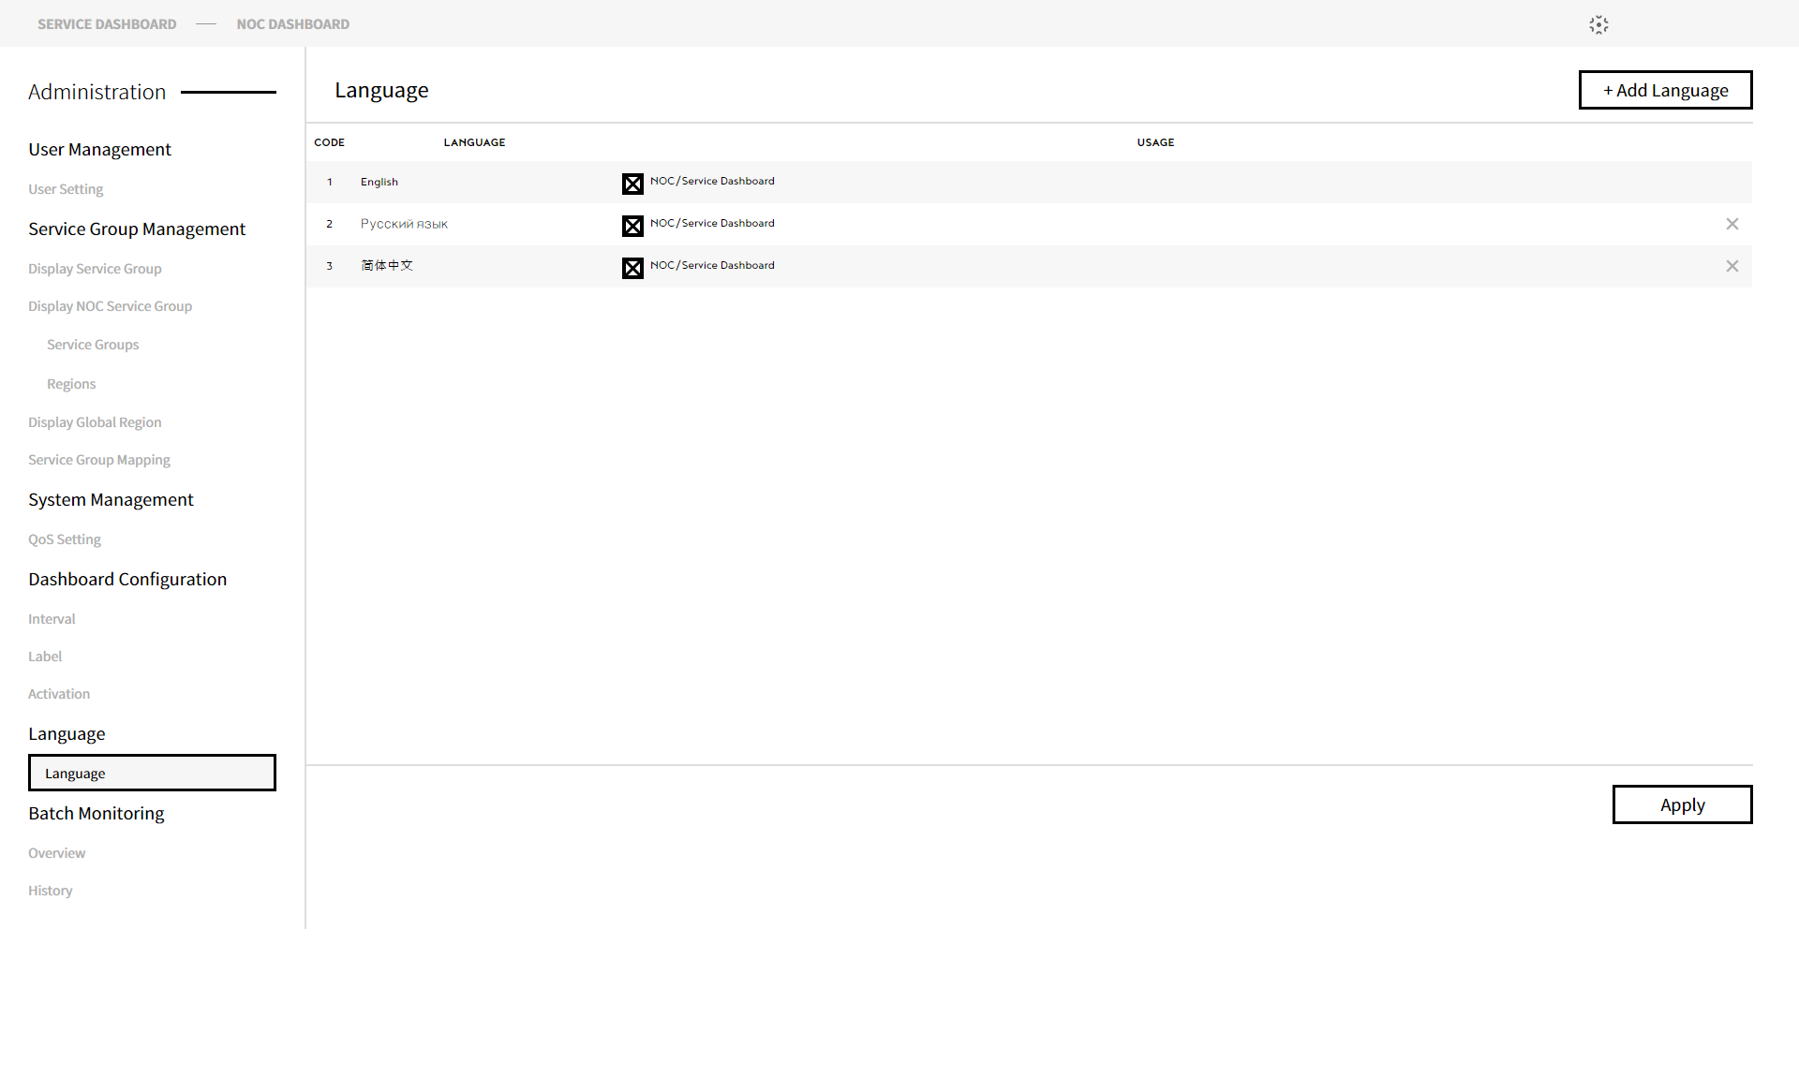

* 1. Batch Monitoring
     1. Overview

Shows the current batch summary details.

Monitoring Dashboard > Administrator > Batch Monitoring > Overview

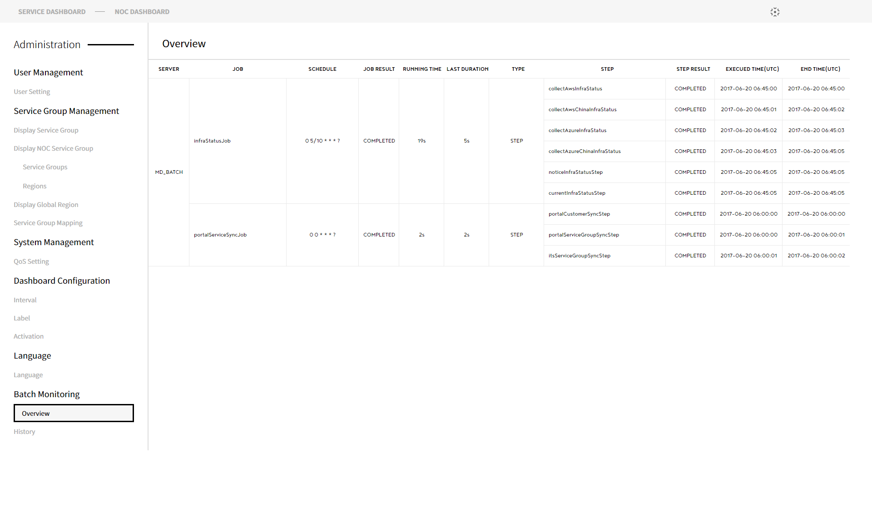

* + 1. History

Shows the history of the current batch in execution.

Monitoring Dashboard > Administrator > Batch Monitoring > History

